LOGIN PAGE (As user)

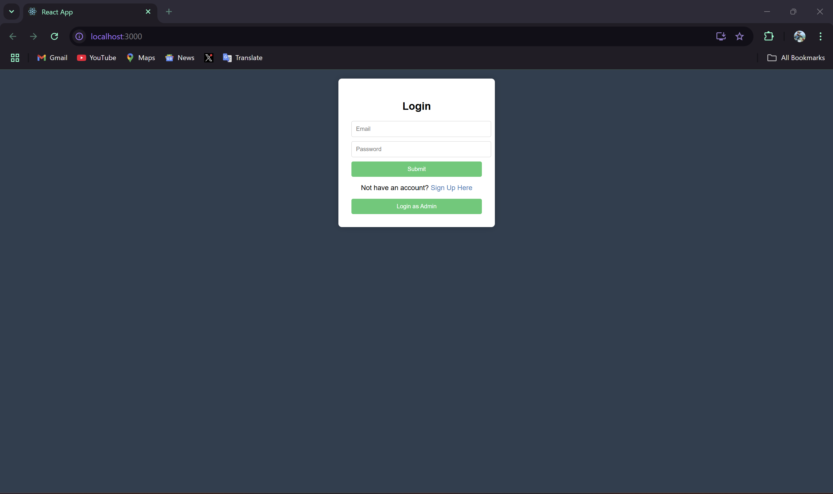

SIGN UP PAGE(For registration of new user)  
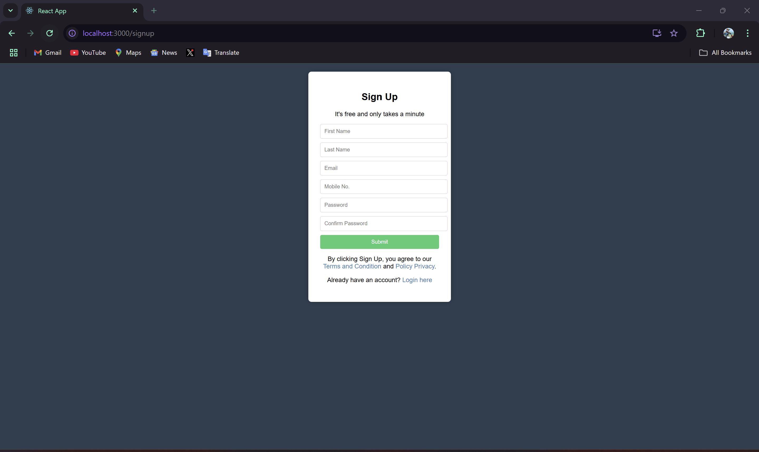

As of now, we only have only one users, and will be creating a new one:

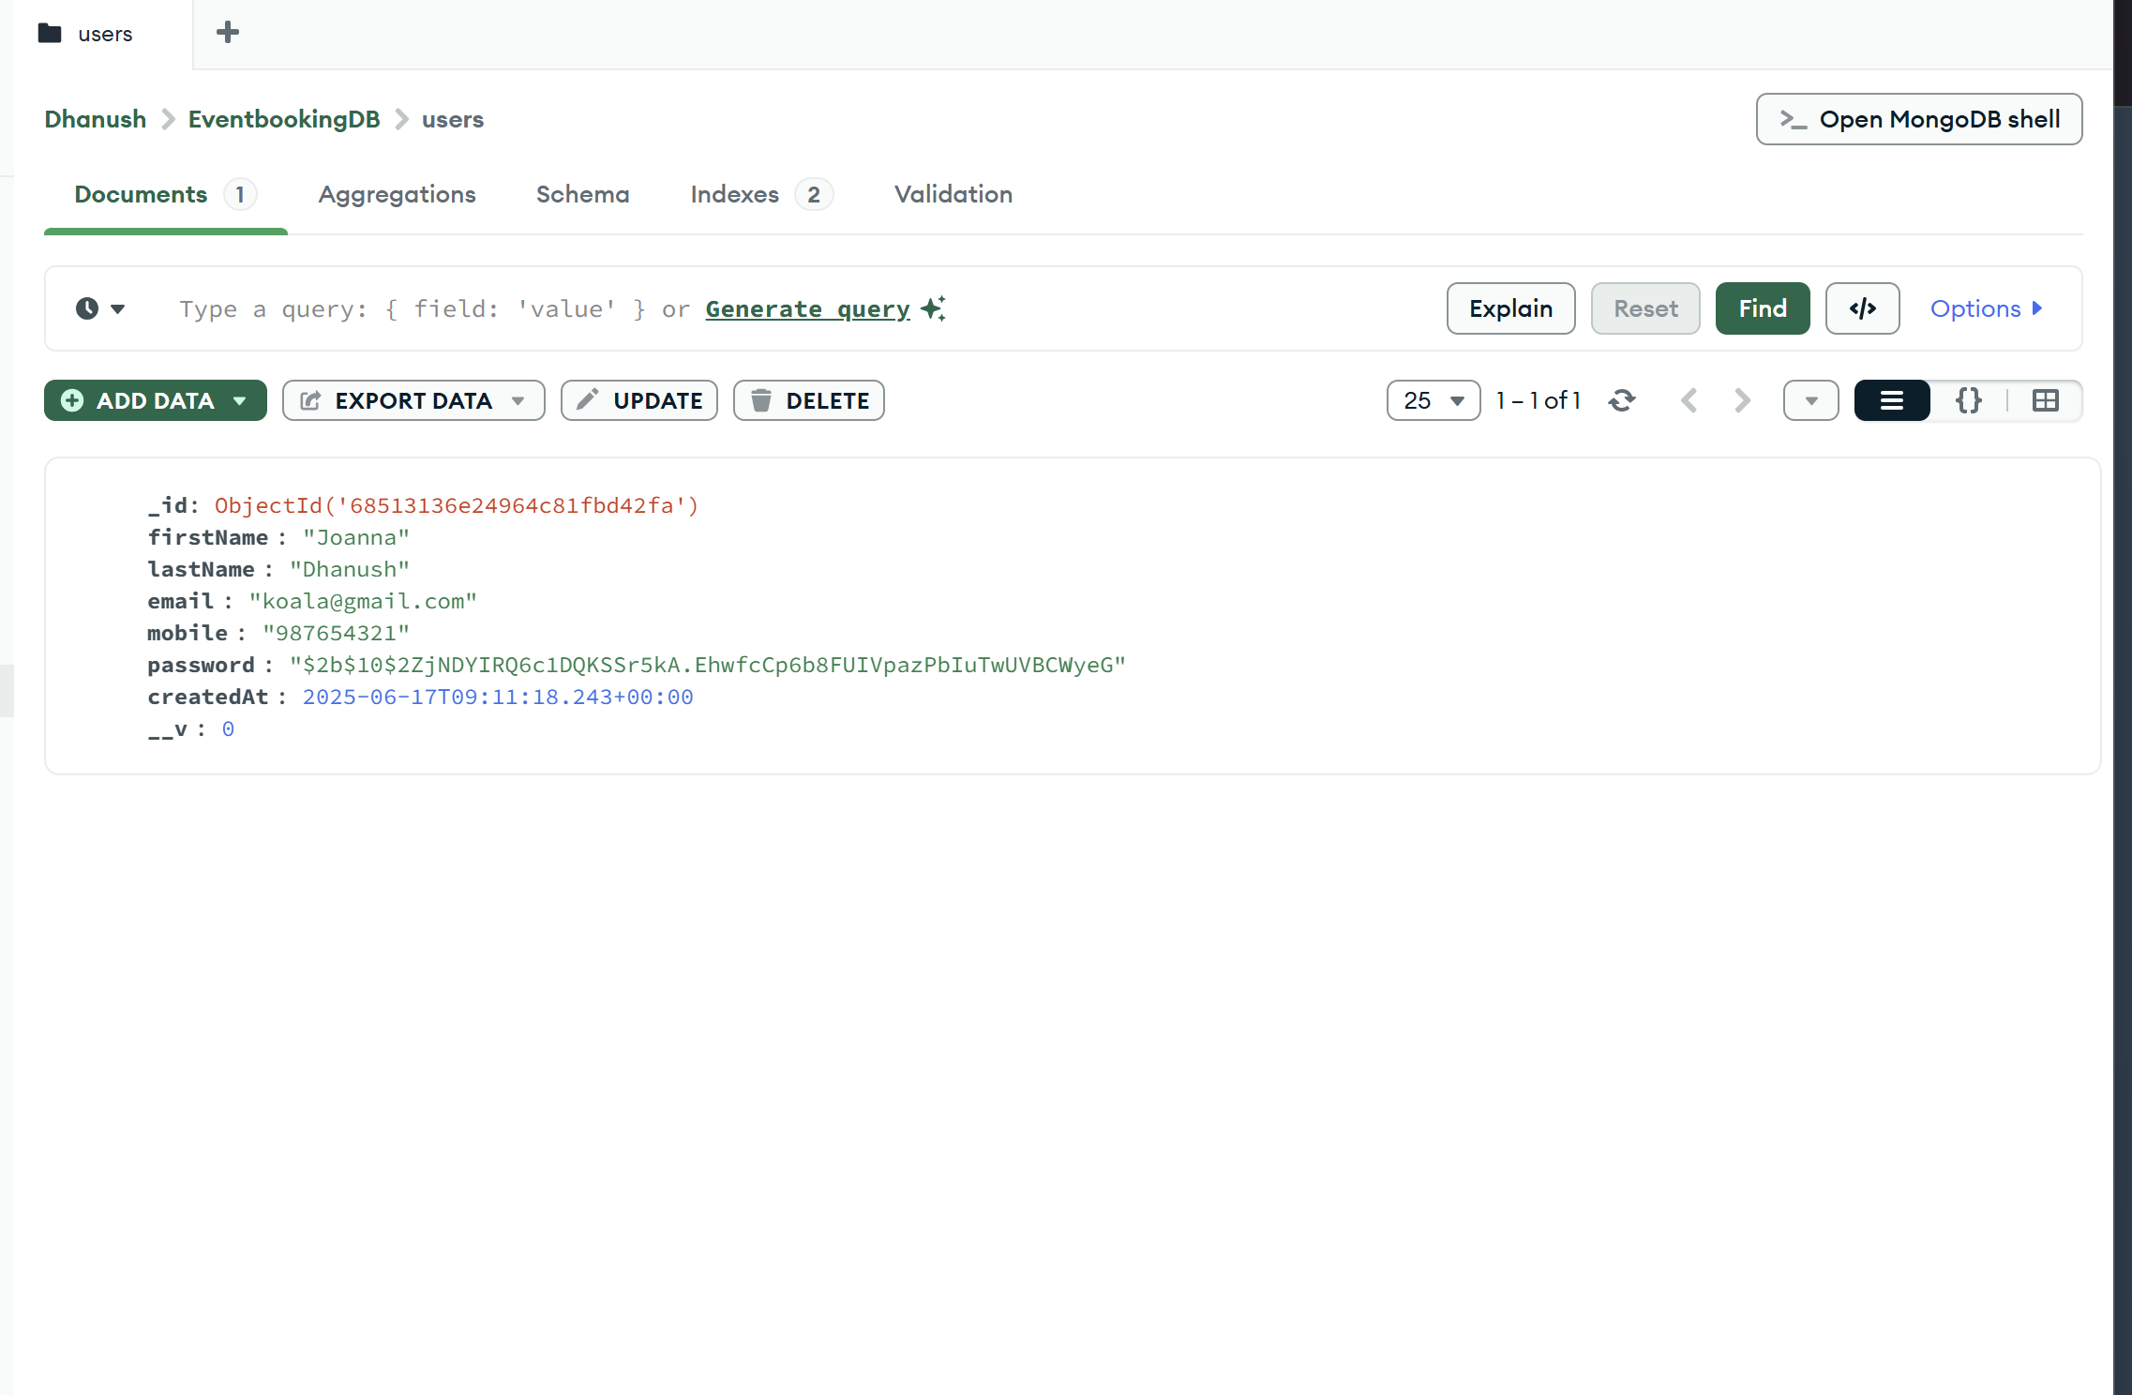

Inserting a new user  
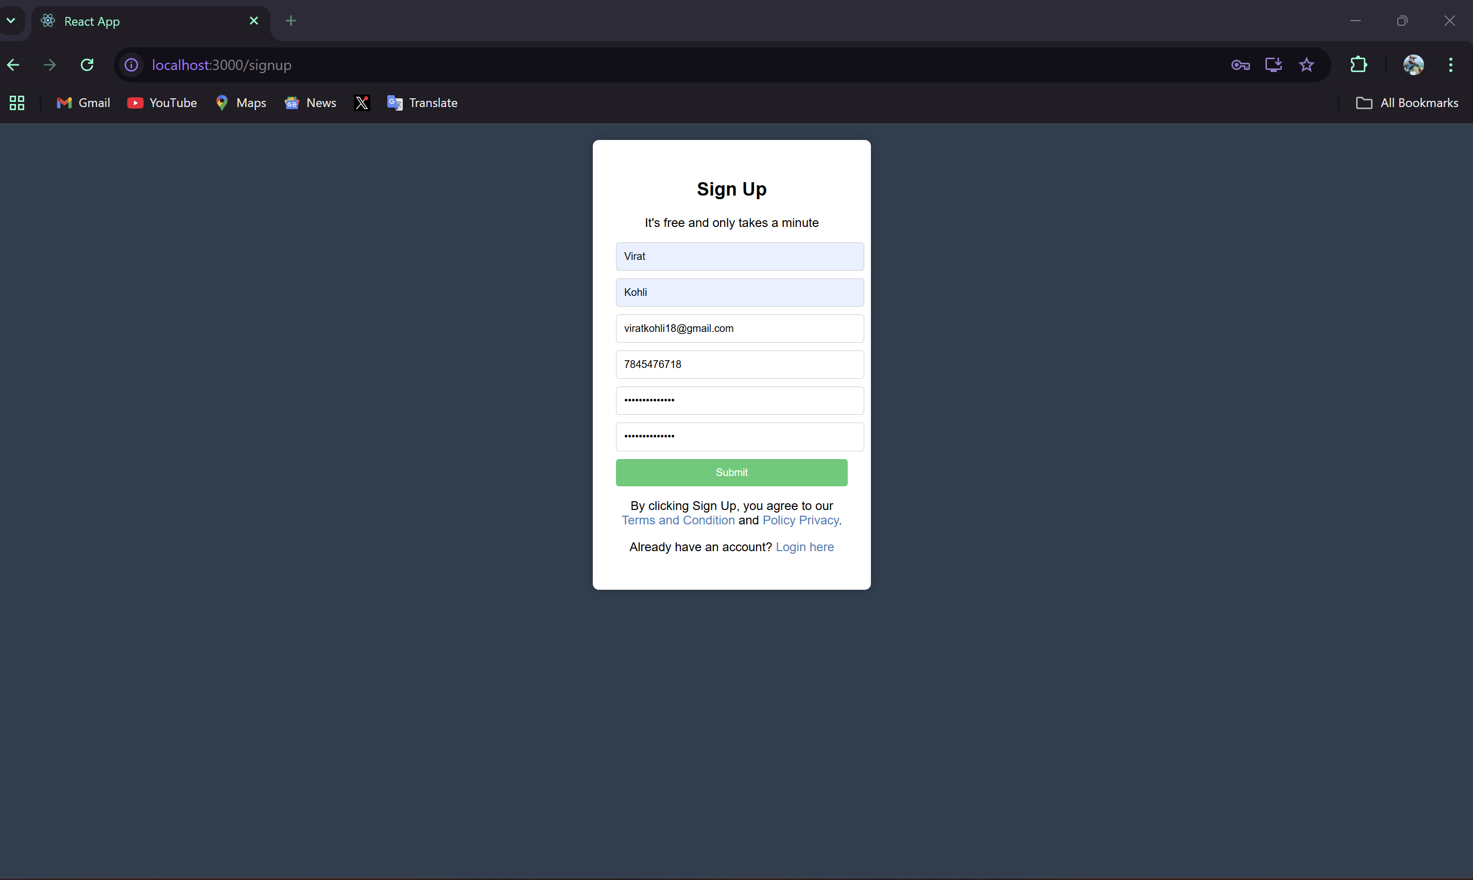

Registered Successfully  
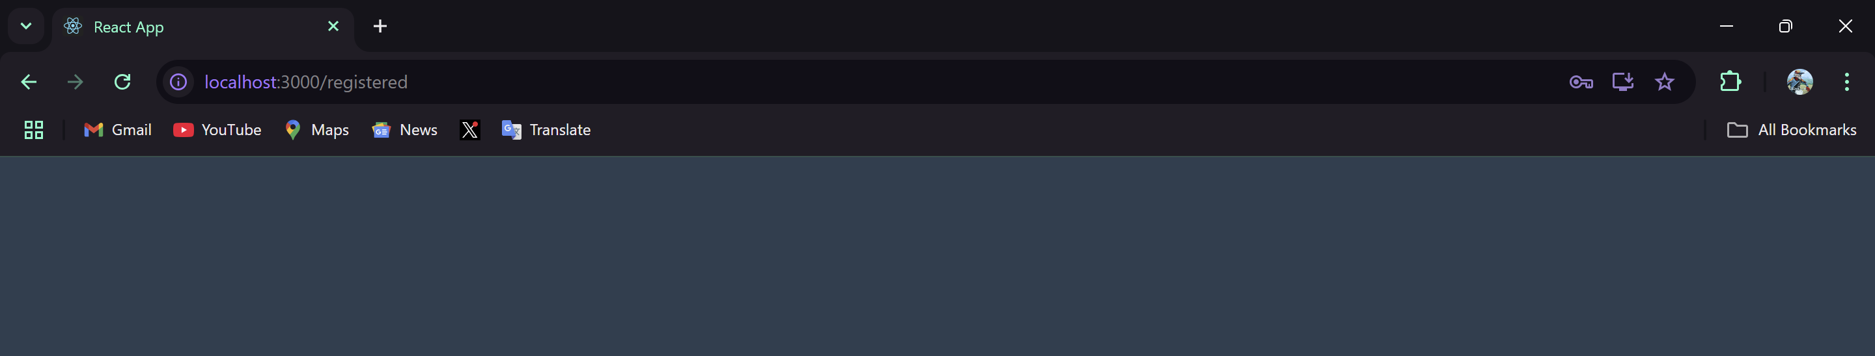

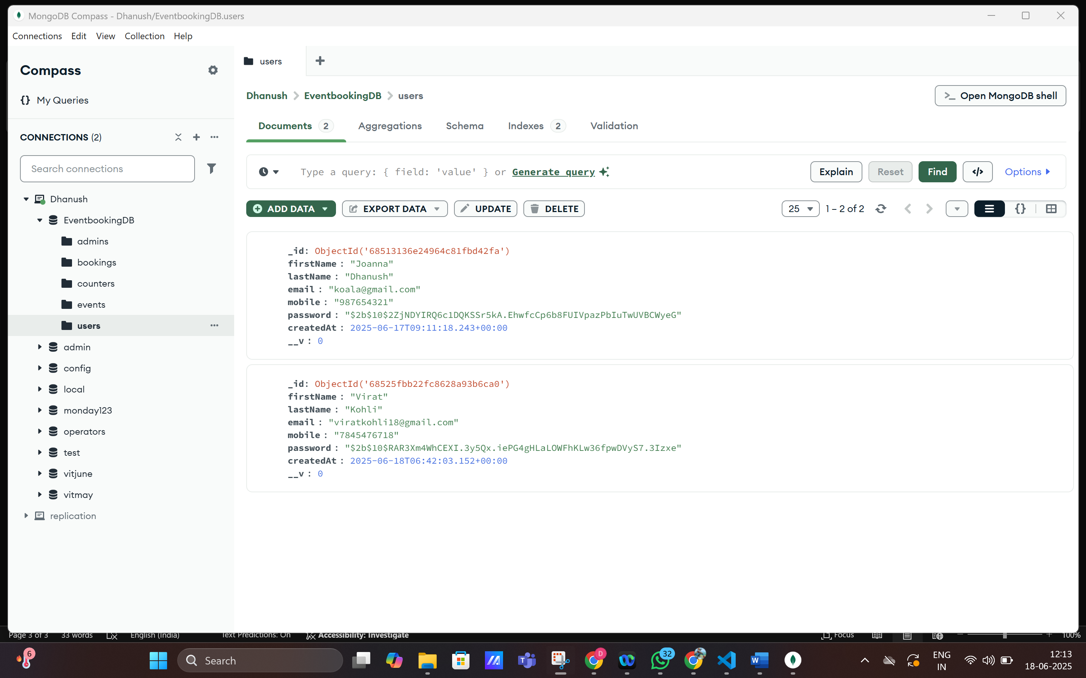

Now logging in with the newly registered user.

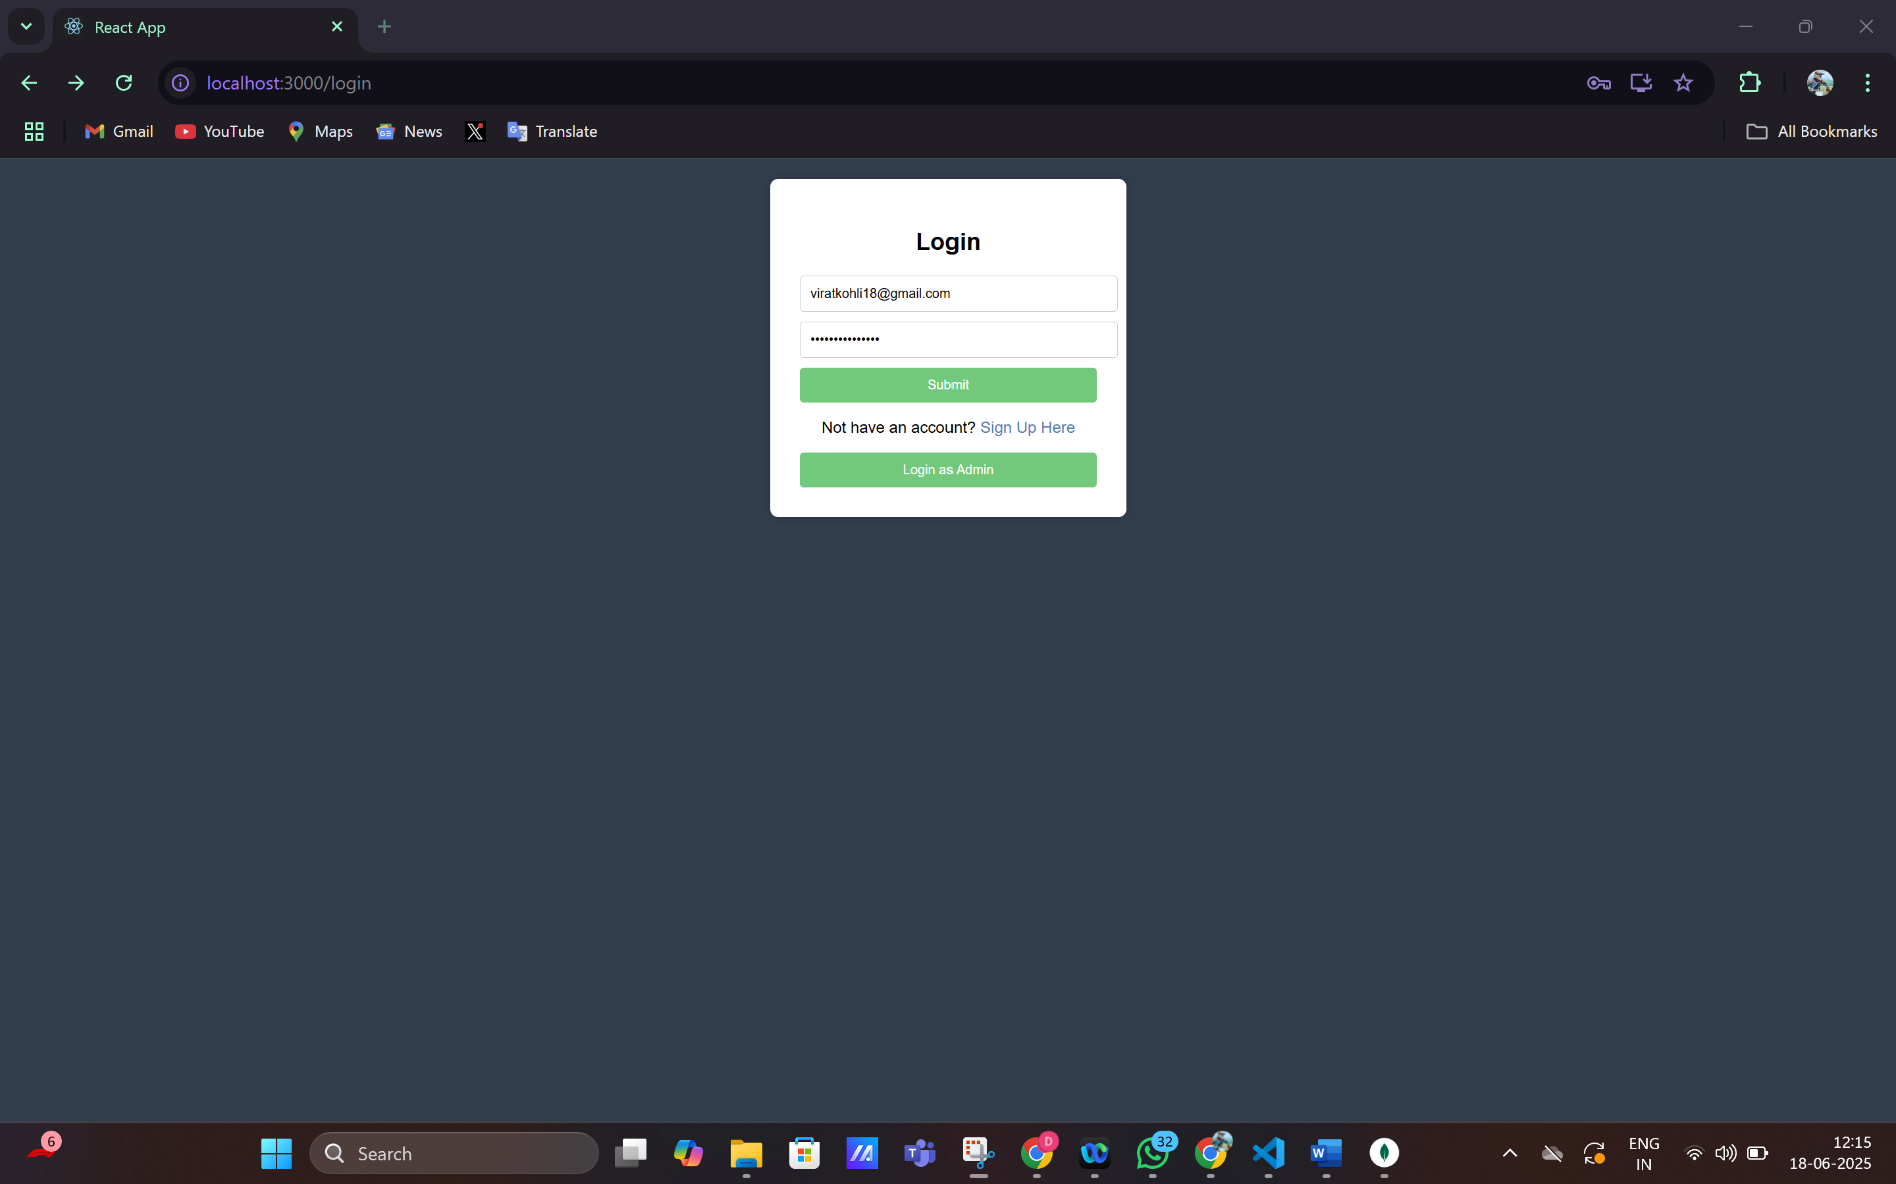

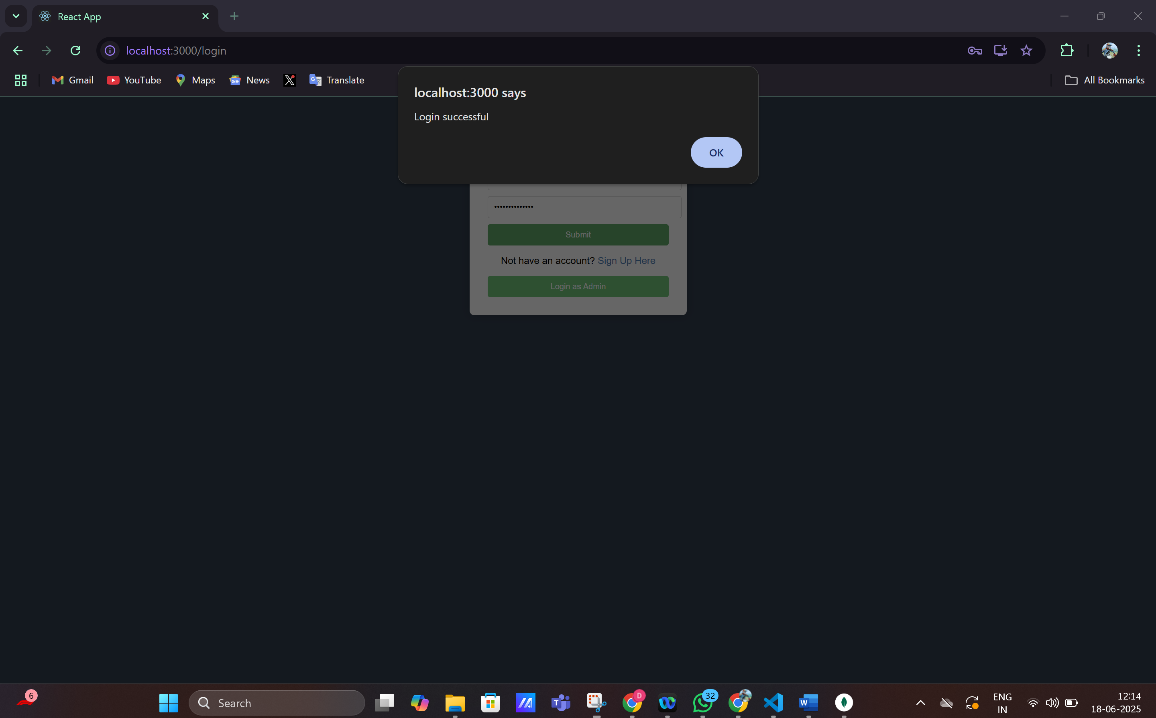

User Dashboard

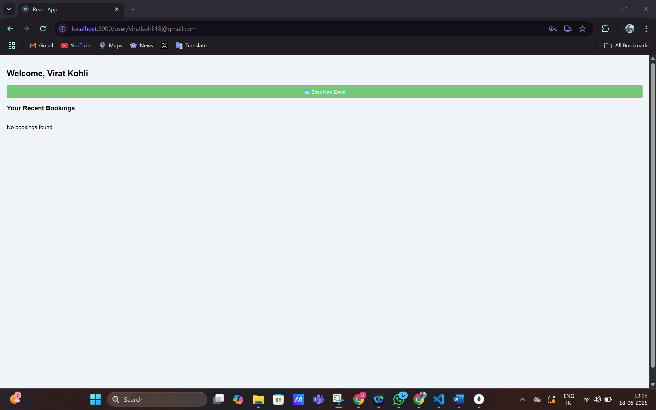

Since the user had no bookings, the recent bookings list is empty. So let’s book an event.

The event database:  
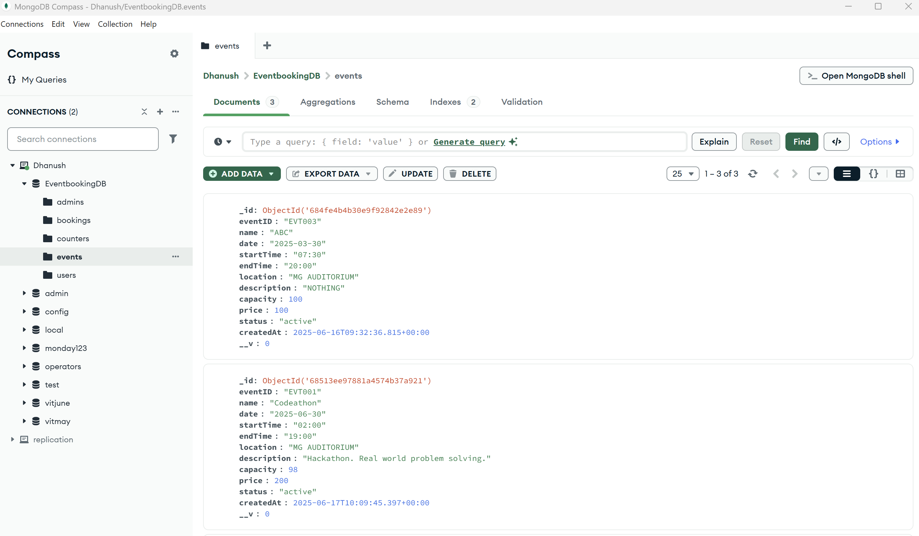

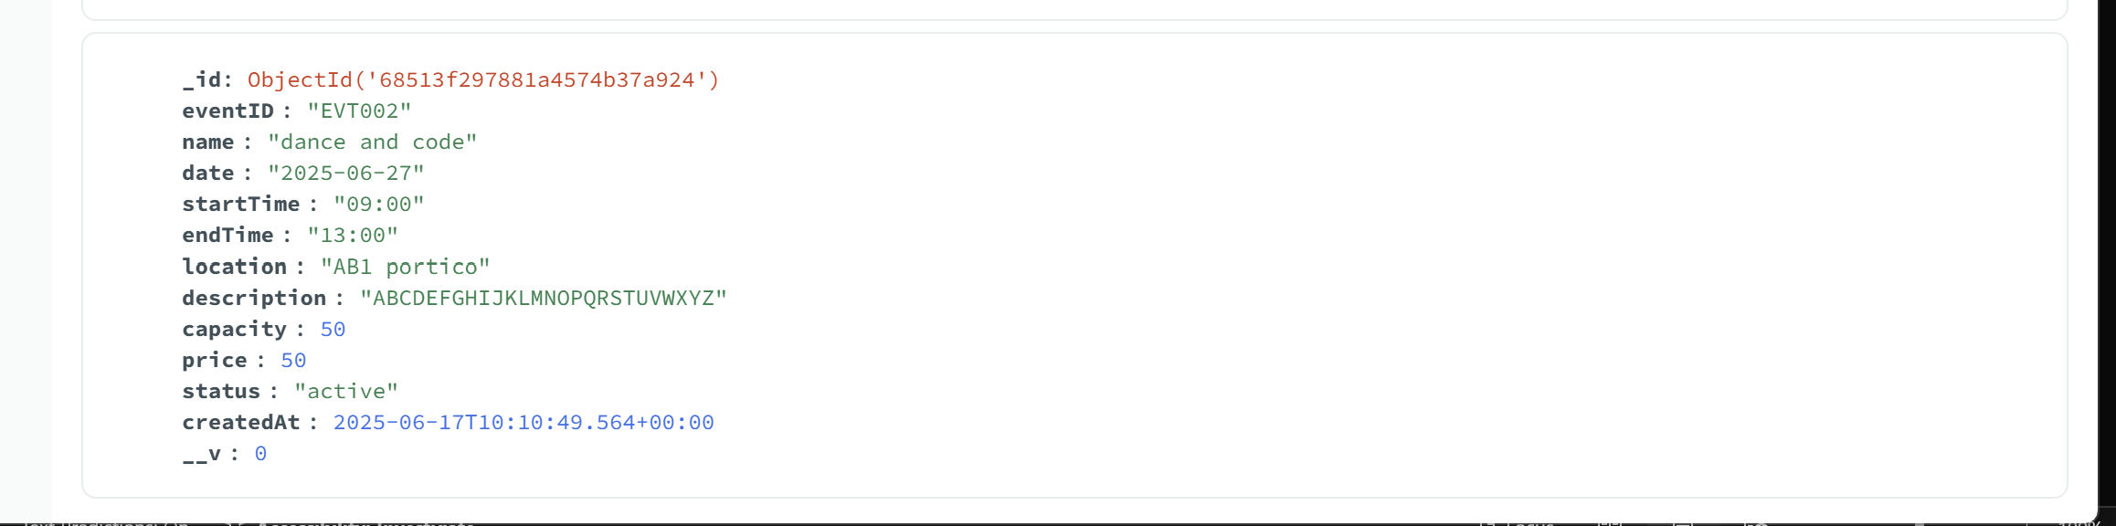

It was three events. But one event had already been completed on 2025-03-30. In the new booking page only two future events will be listed.

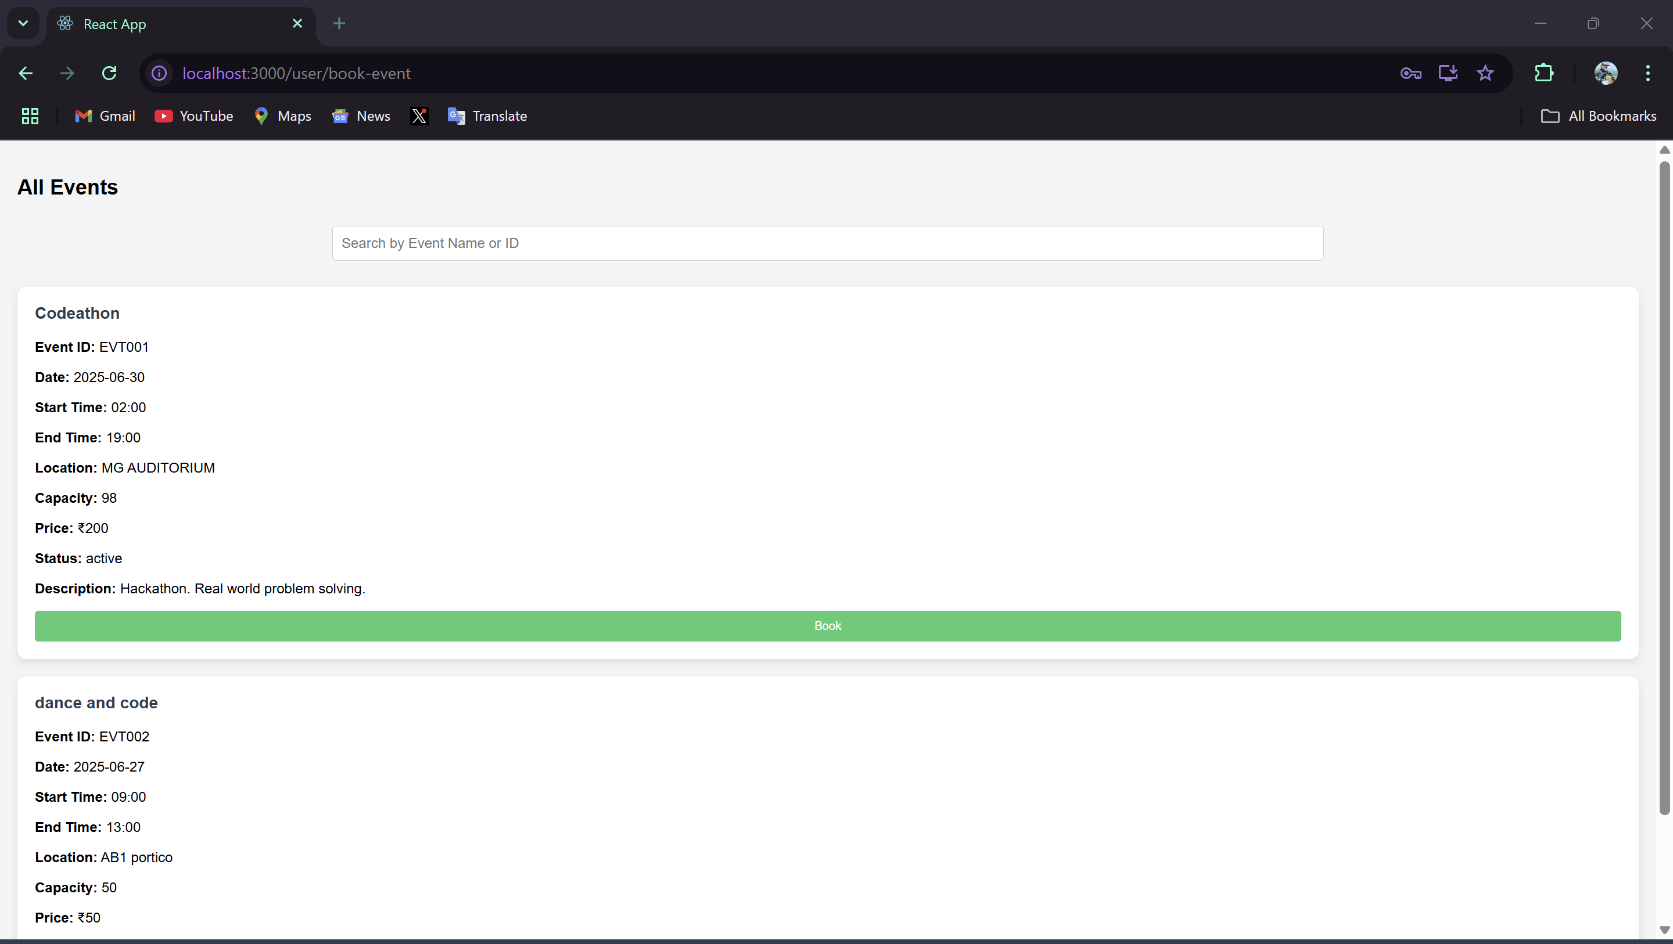

The search bar can be used for viewing the events too

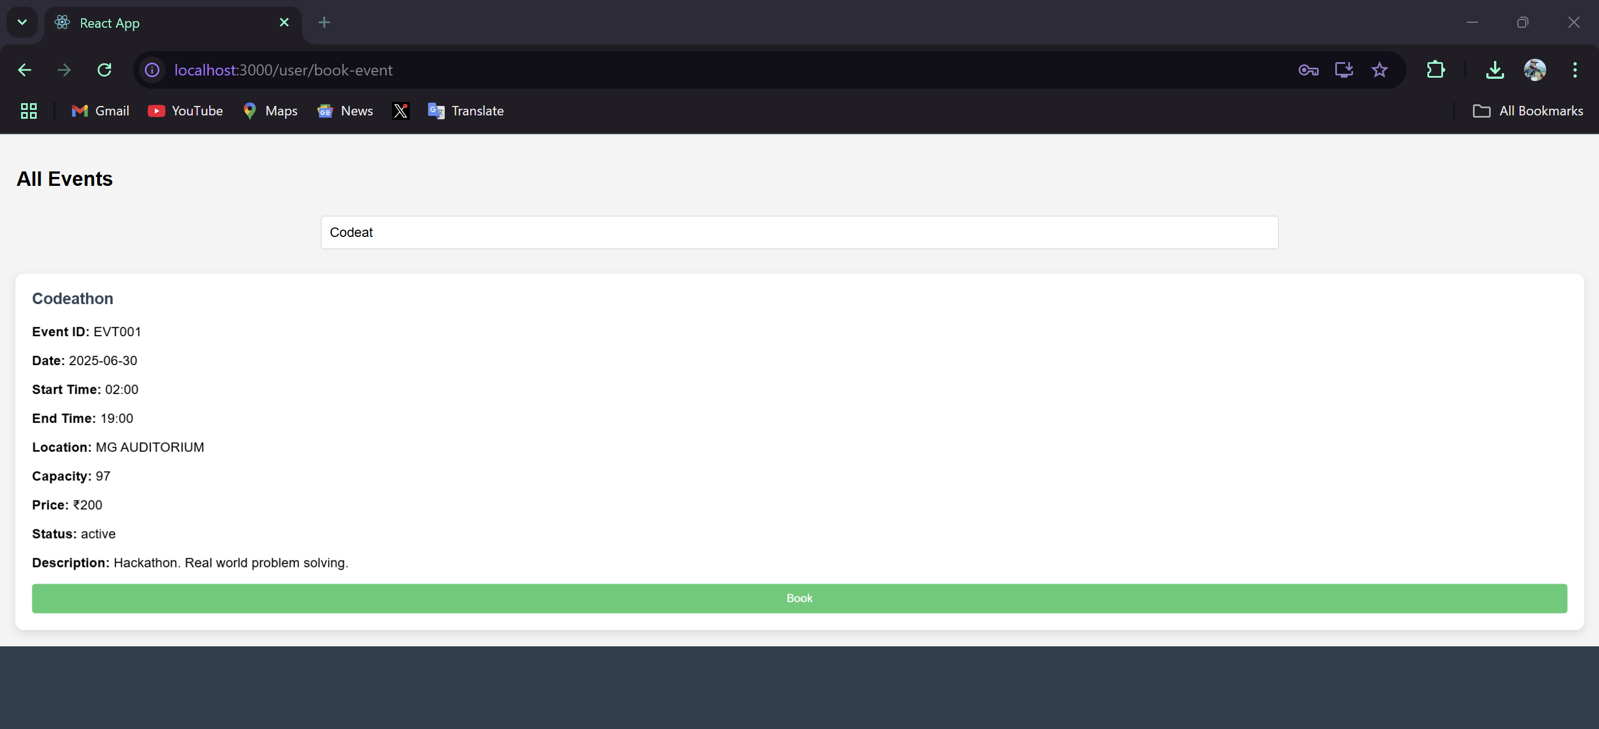

Booking…  
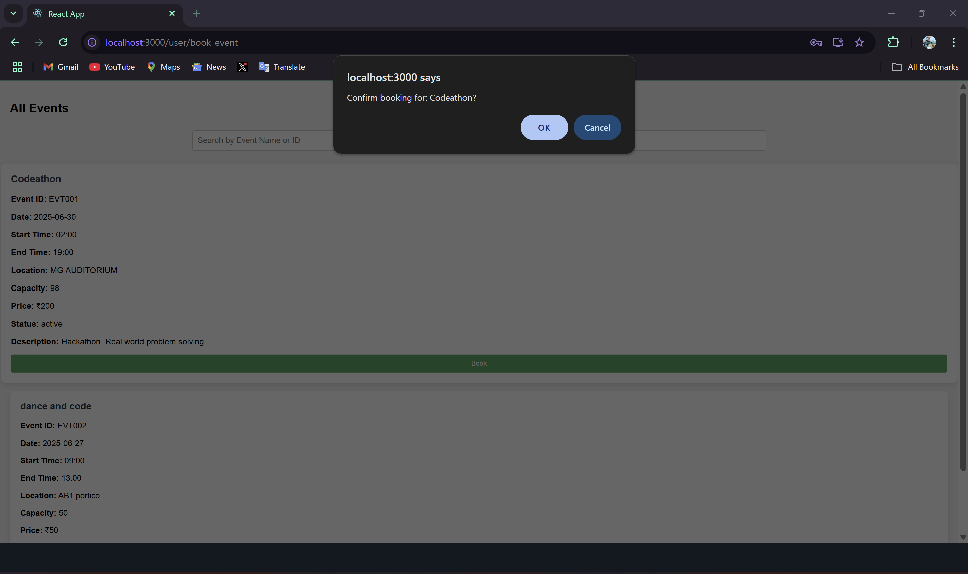

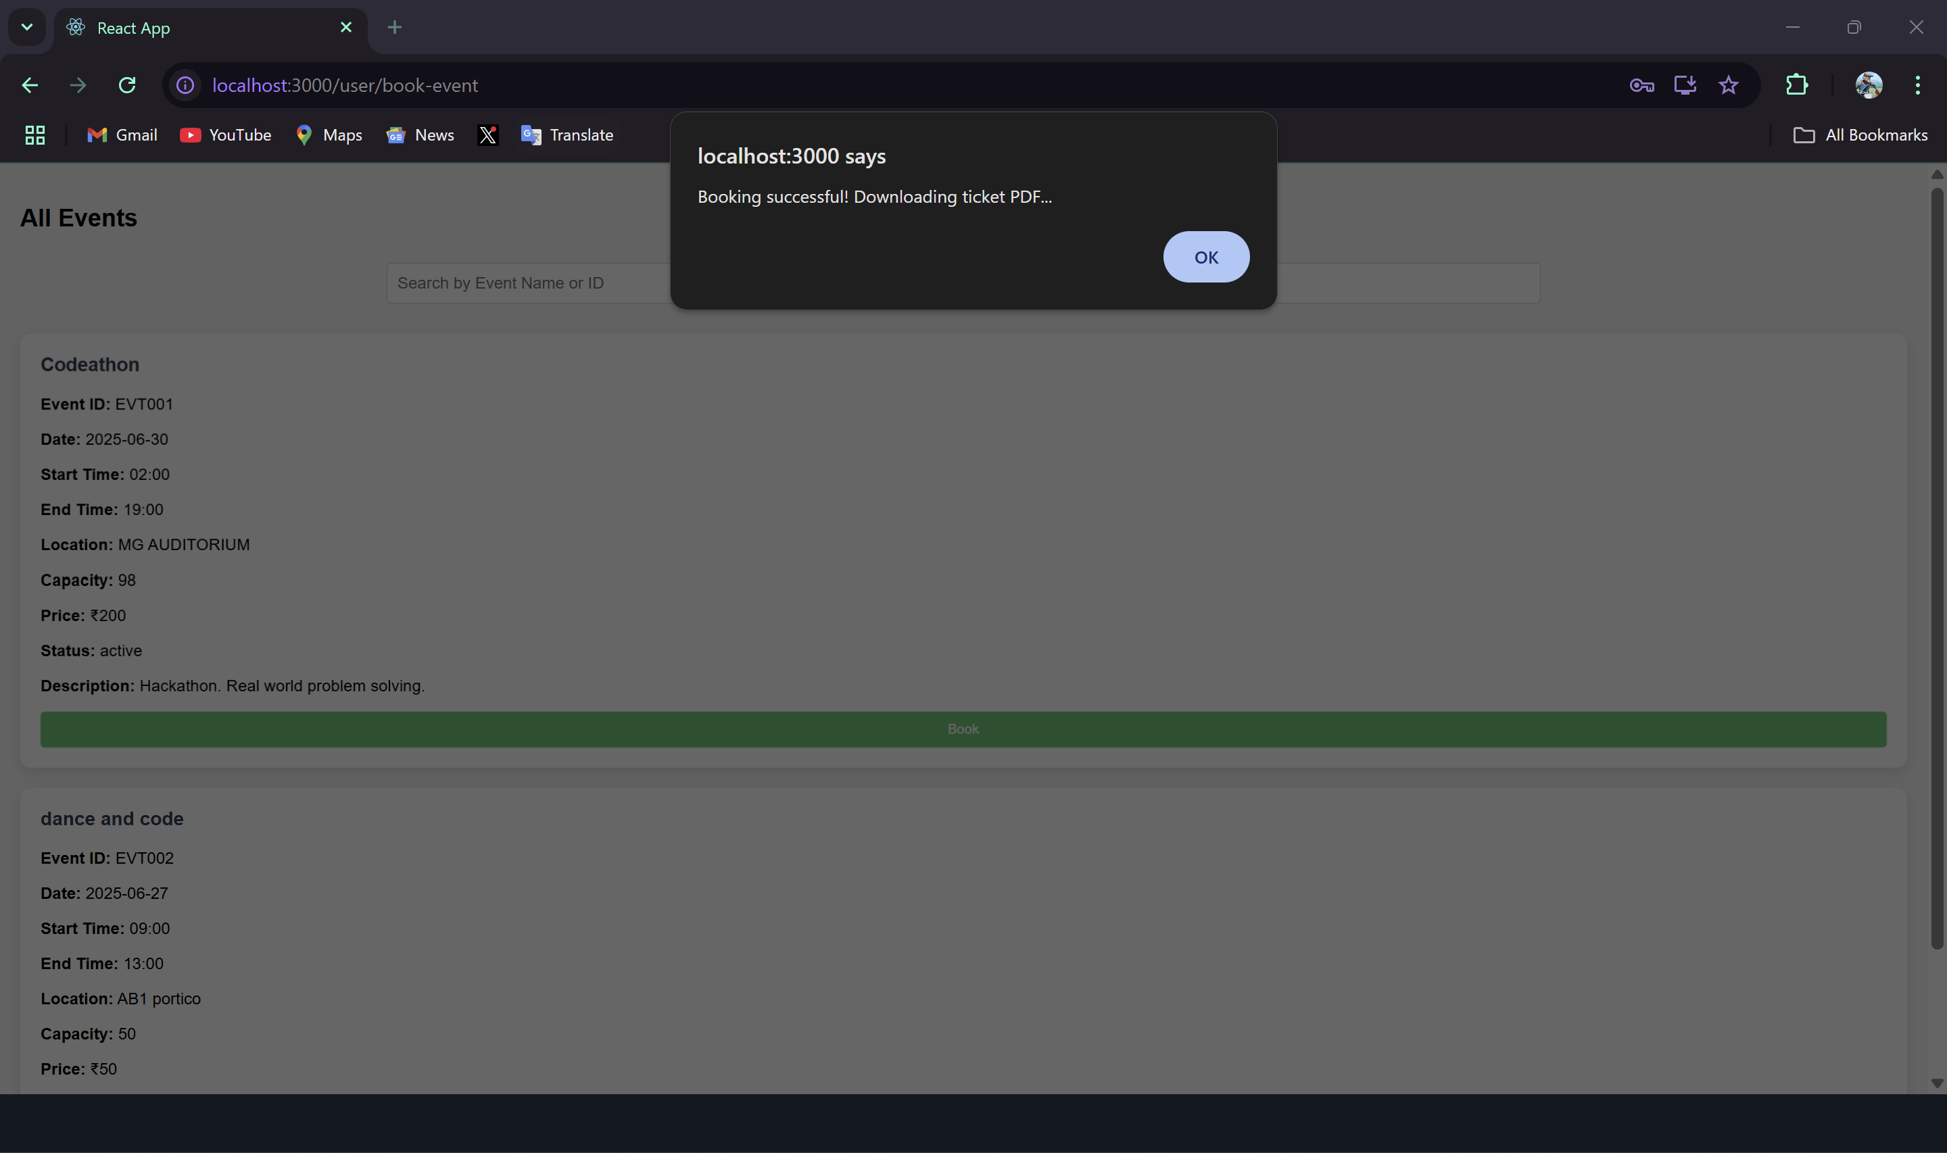

PDF COPY OF THE TICKET:  
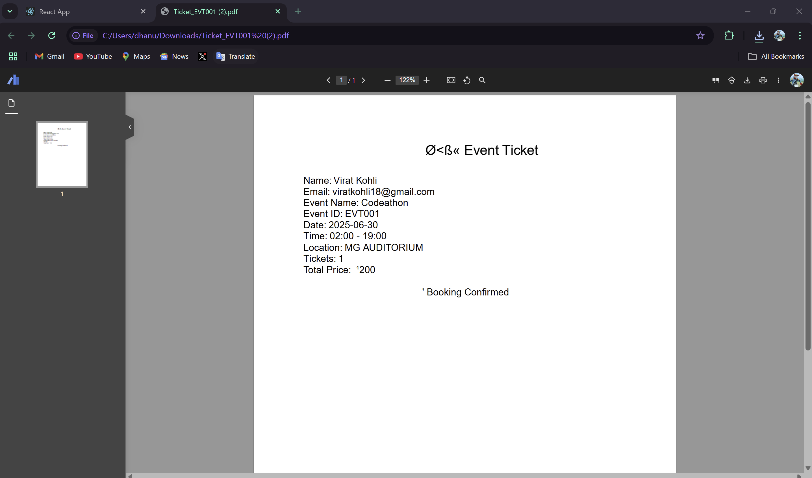

Now, the recent bookings have an event listed.

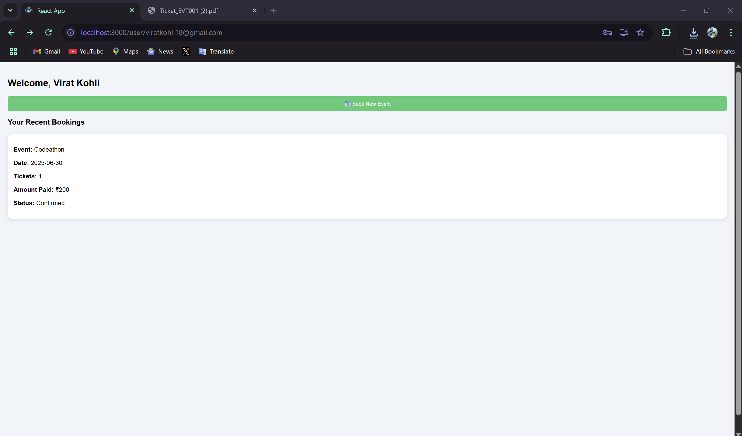

And also in the collections, you can notice that the capacity of the has reduced by count of one.

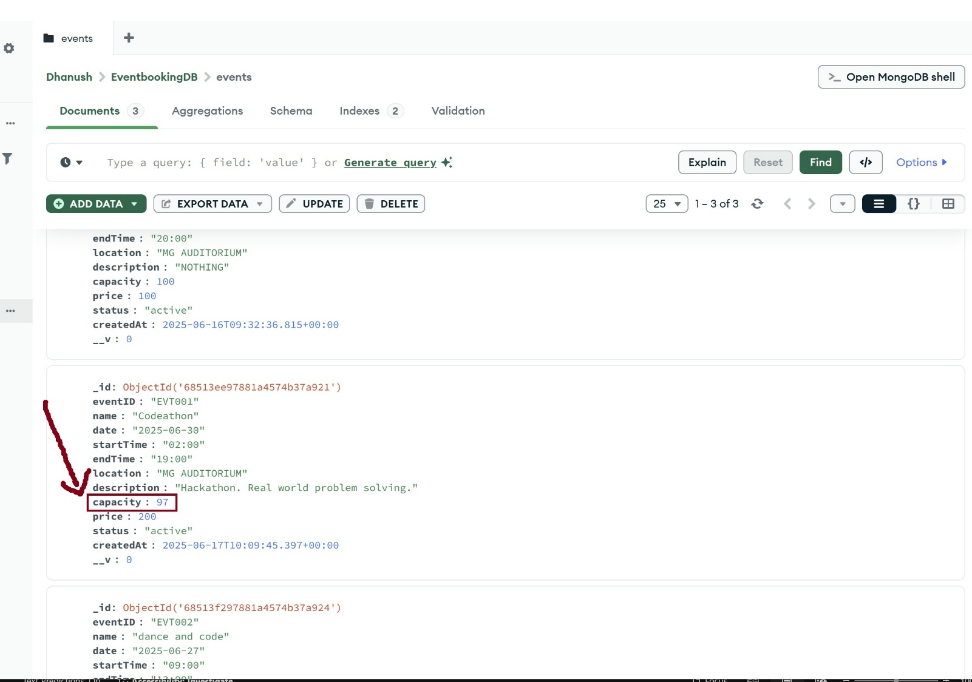

And the list of Recent bookings in given by the collection Bookings.  
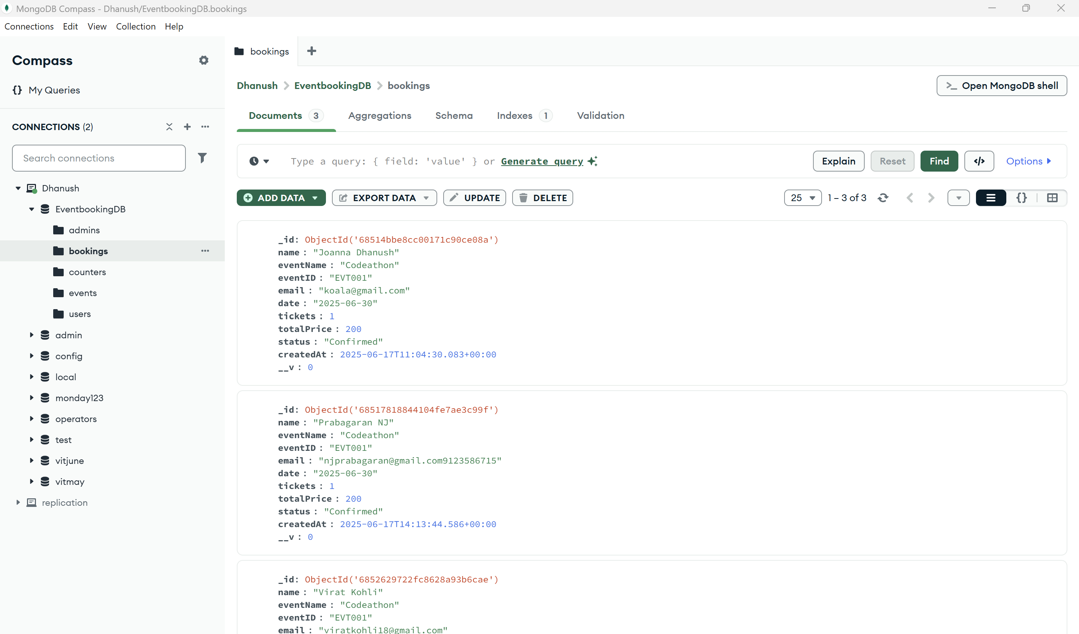

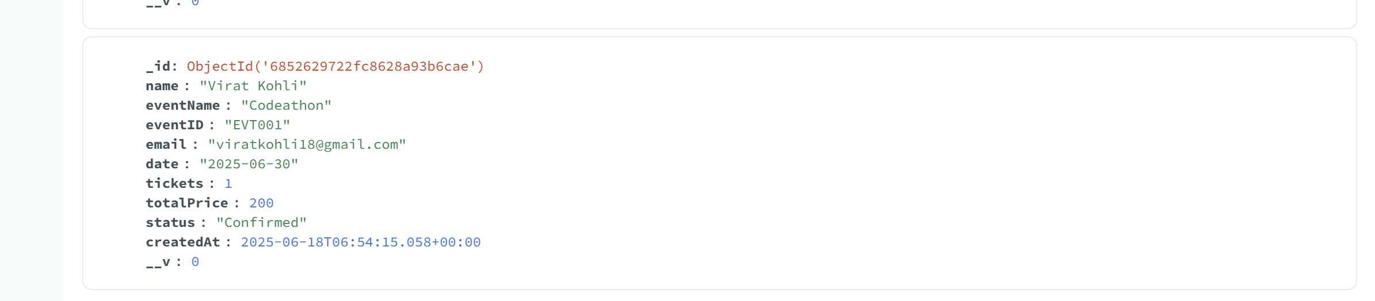  
  
  
  
  
  
  
  
  
  
  
  
  
  
  
  
  
  
  
  
  
  
  
  
  
  
  
  
  
  
  
  
  
  
  
  
  
  
  
  
  
  
  
  
  
  
**NOW LOGGING IN AS ADMIN  
The admin has the privilege to add, update, and delete events. The admin can also view the info of all events.**

* In the collection admin, we have only one admin. And only the administration has the privilege to add new admins to the collection, which can be done only in MongoDB Compass.

Admins collection:  
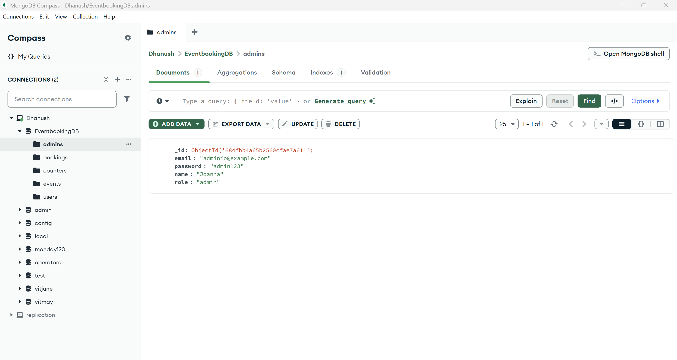

Now logging in:  
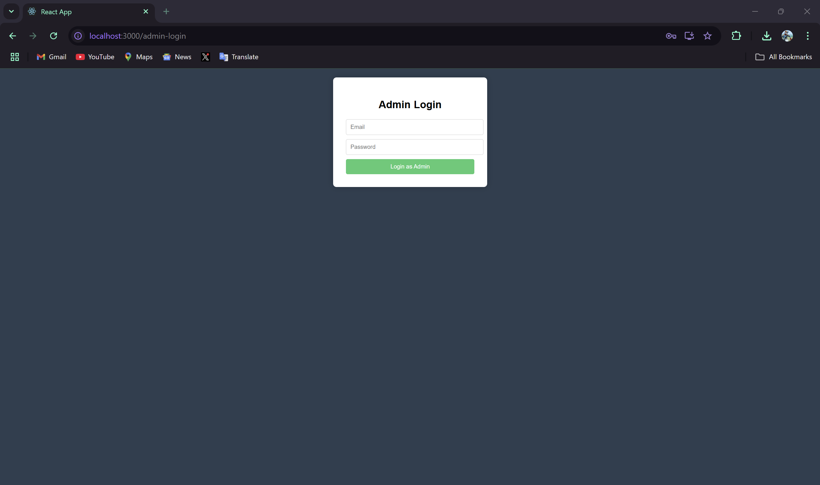

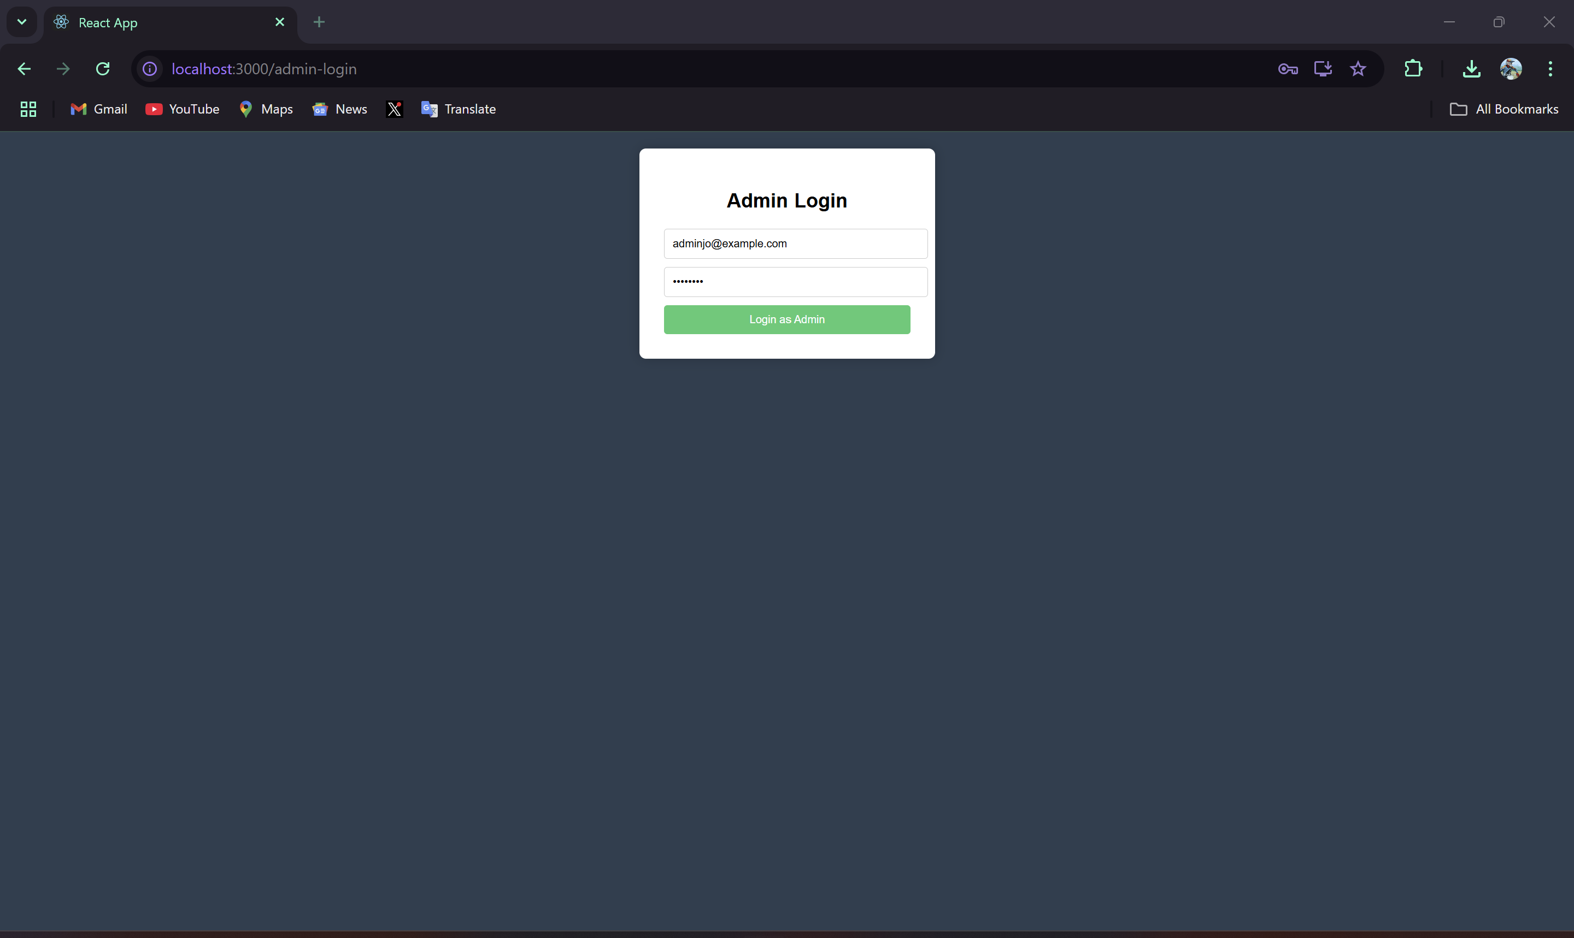

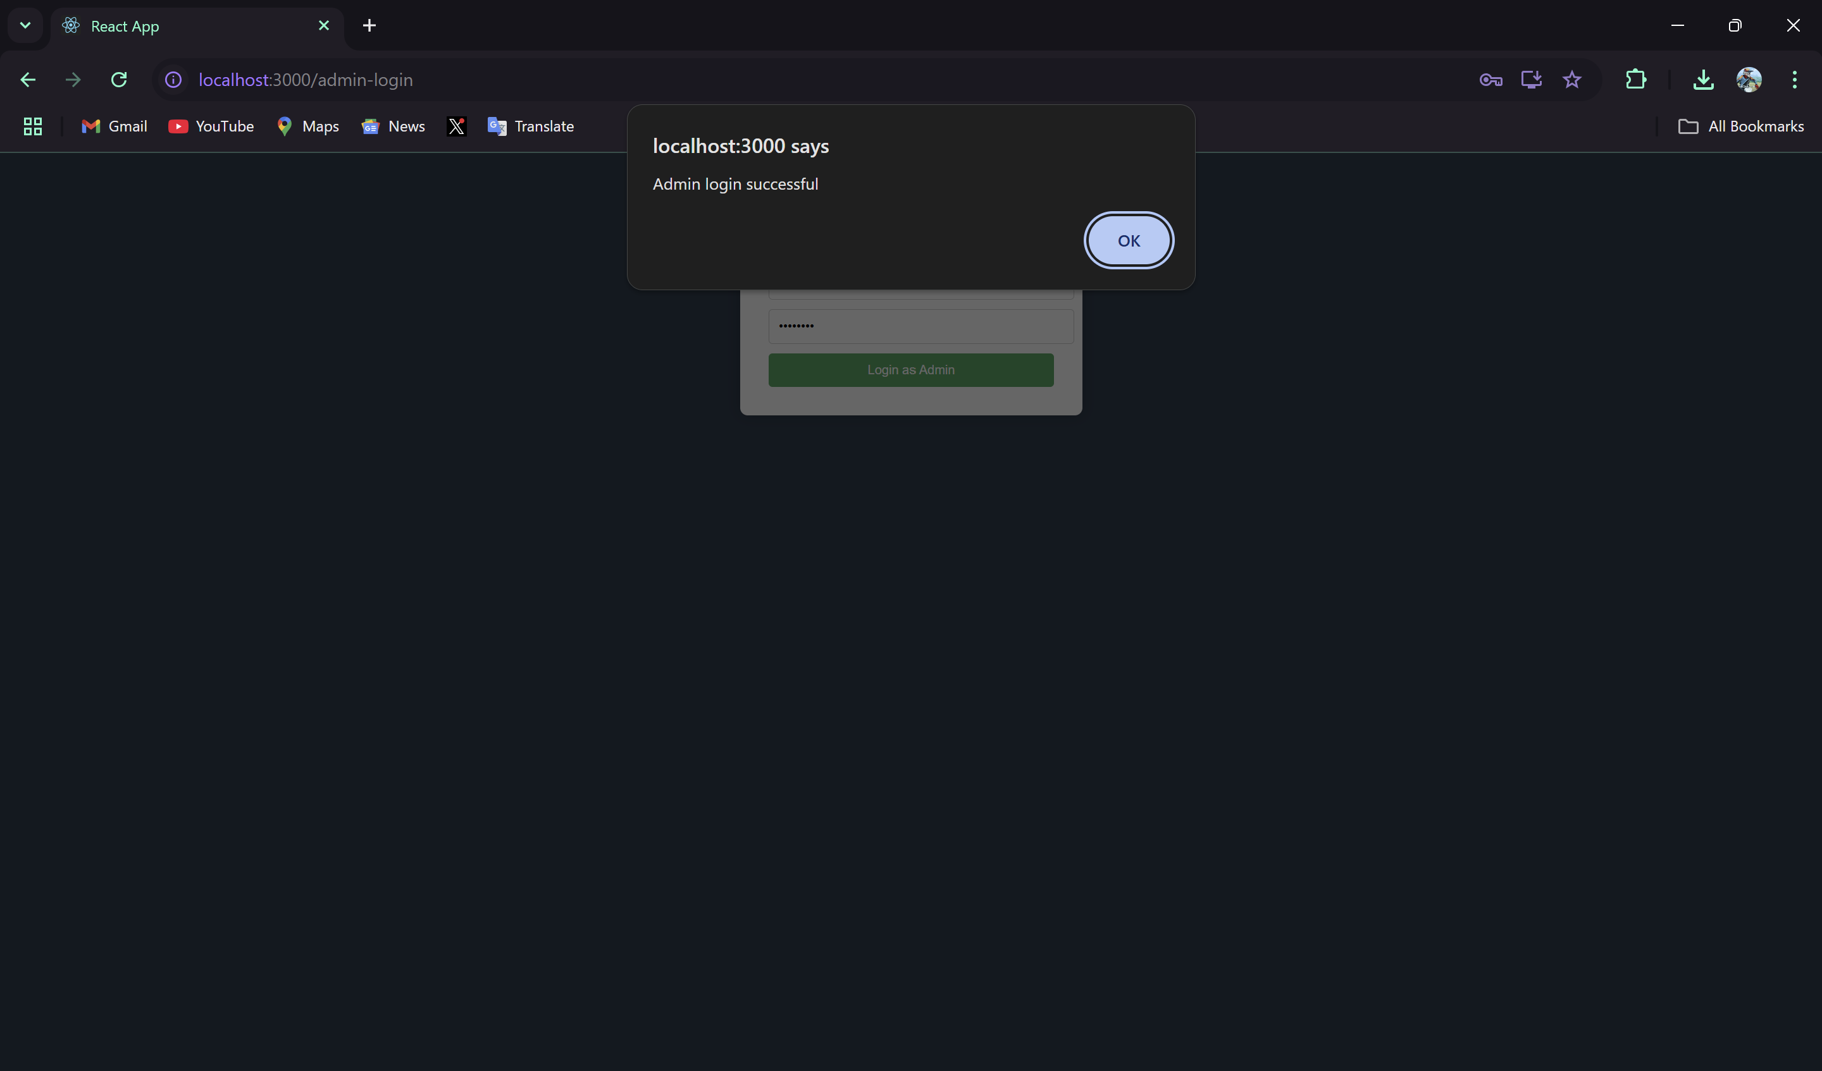

Admin dashboard:  
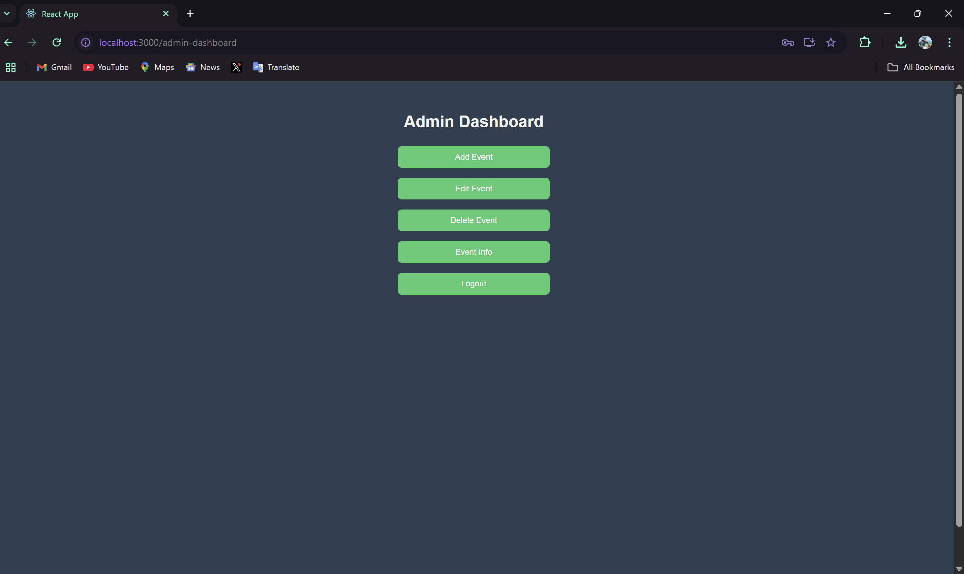

Adding a new event to the collection. It’s already mentioned that there are only three events in the collections  
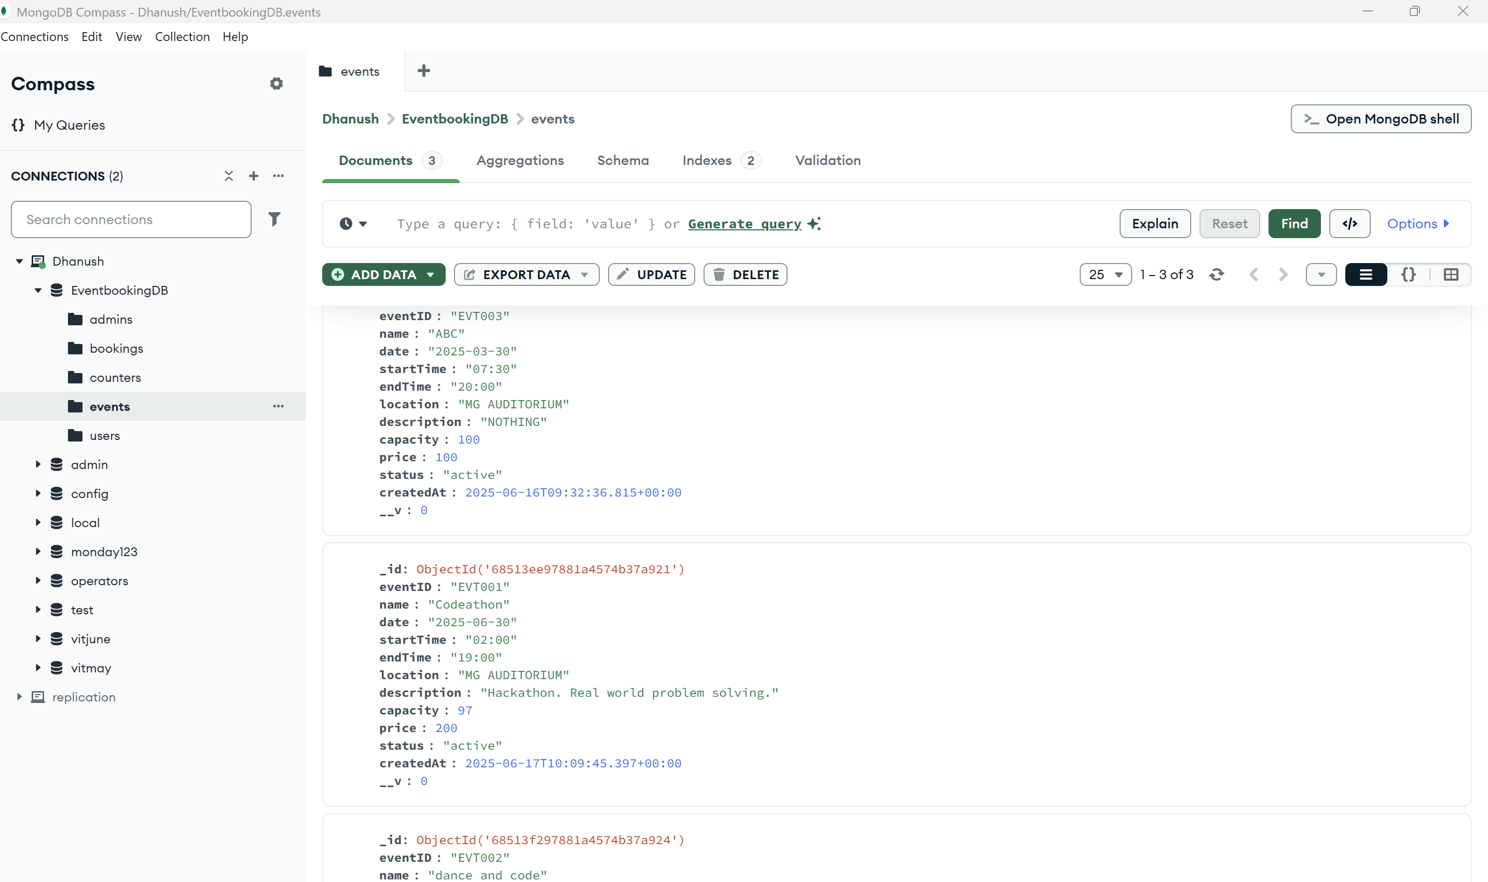

**Adding a new event**  
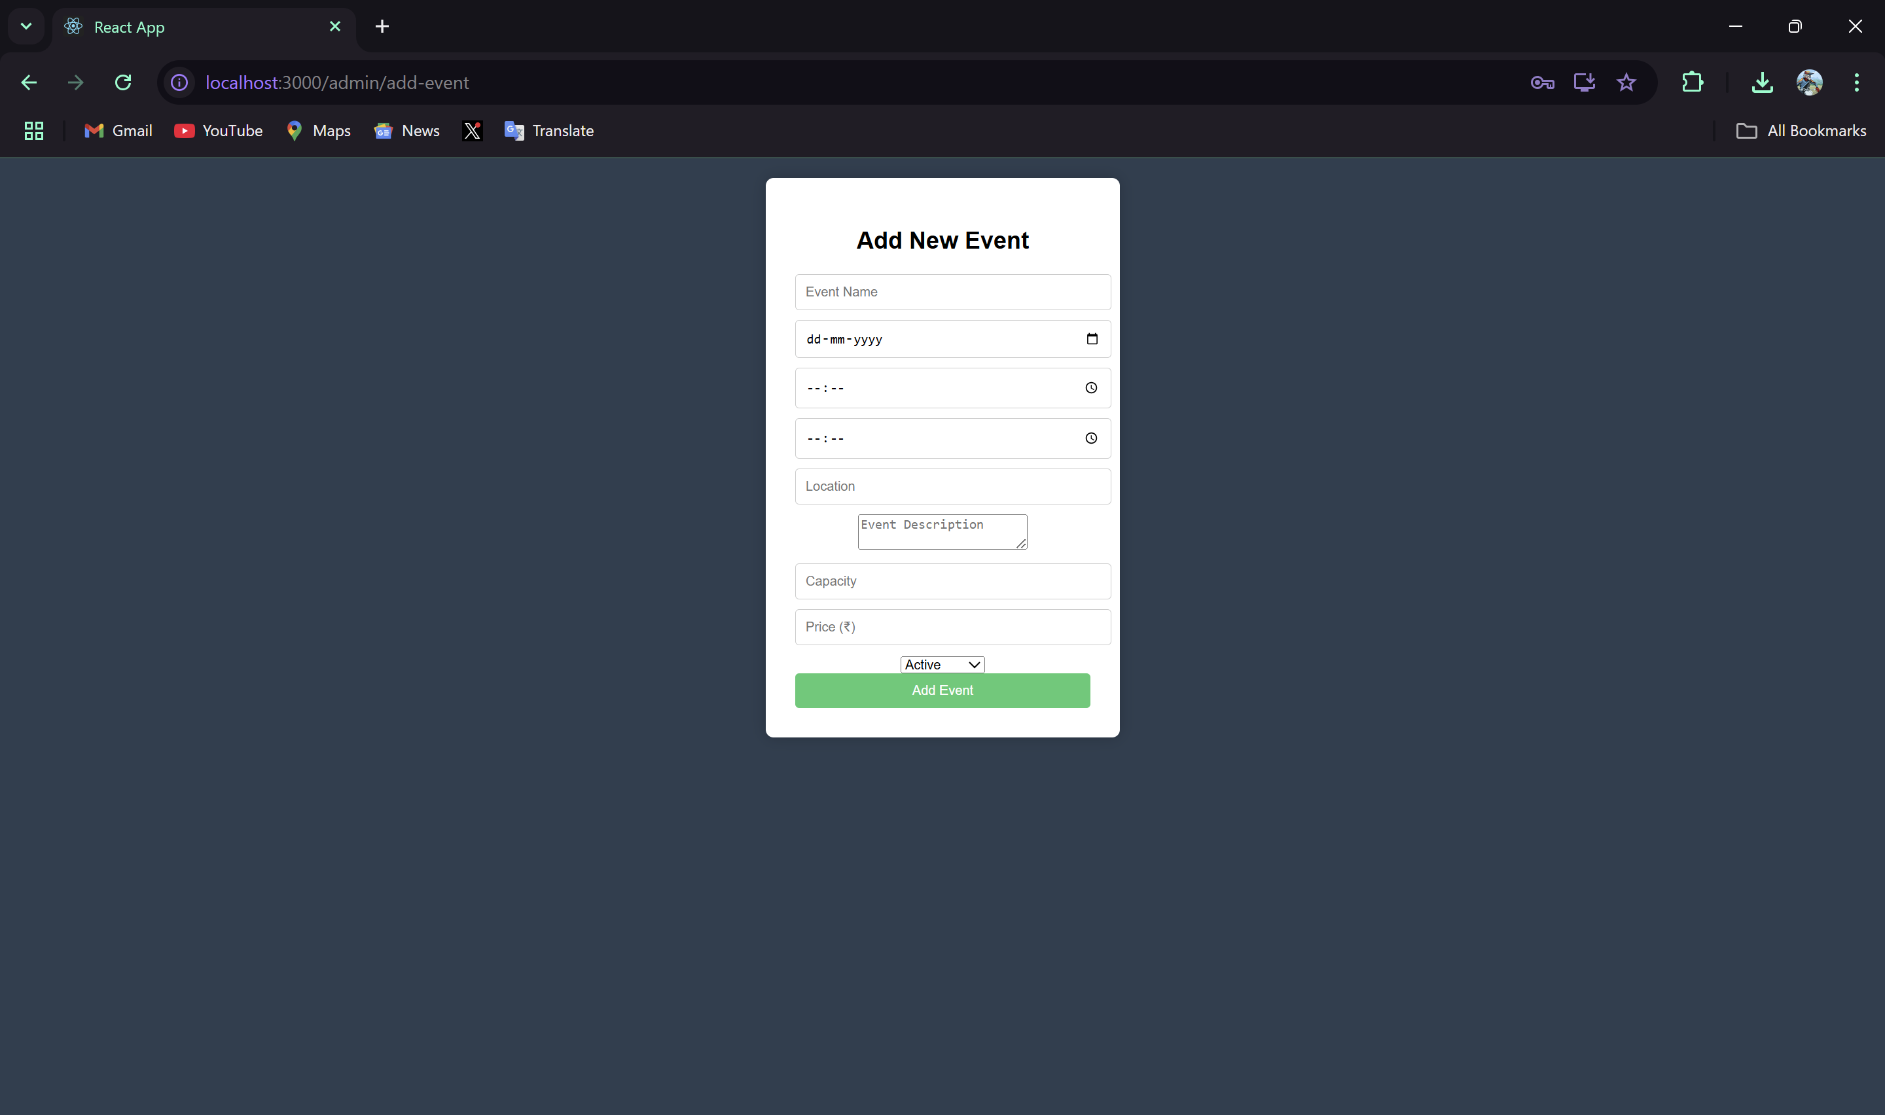

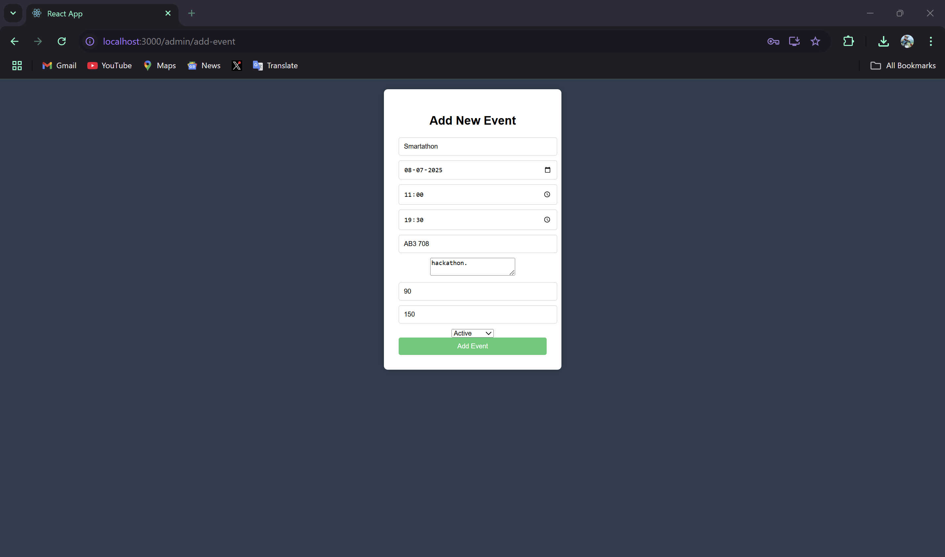

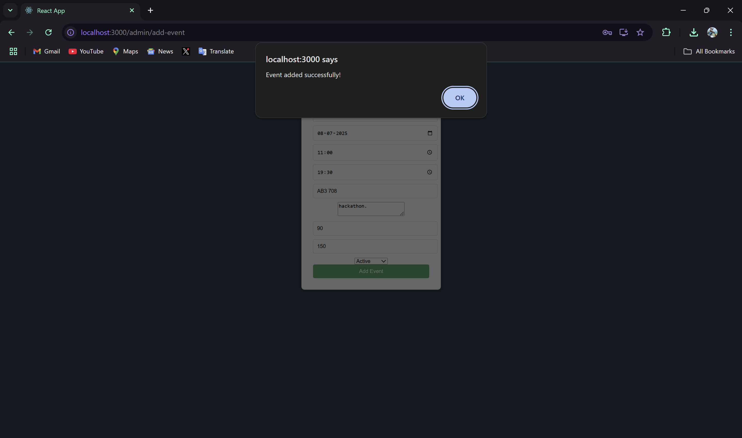

Currently added event:  
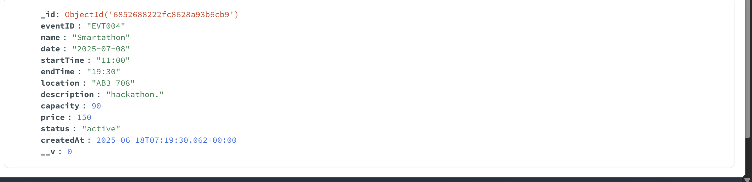

**Updating the info of an event**  
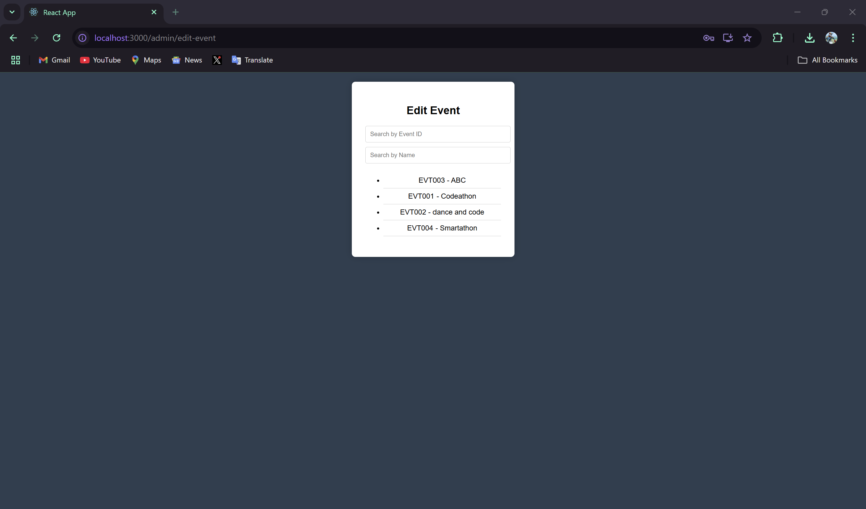

With the help of search bar we can search for the events too.

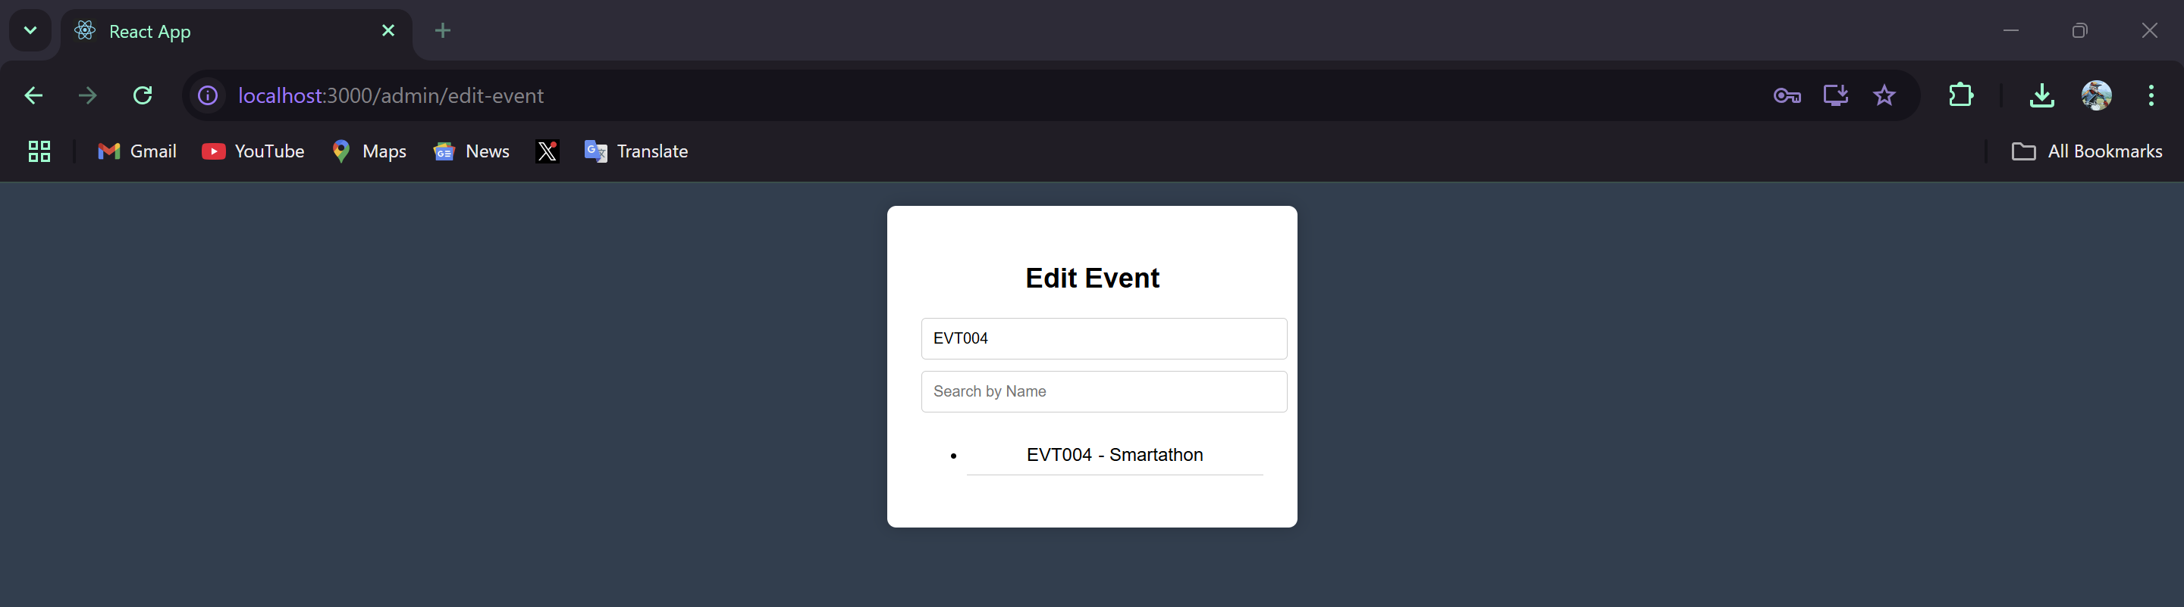

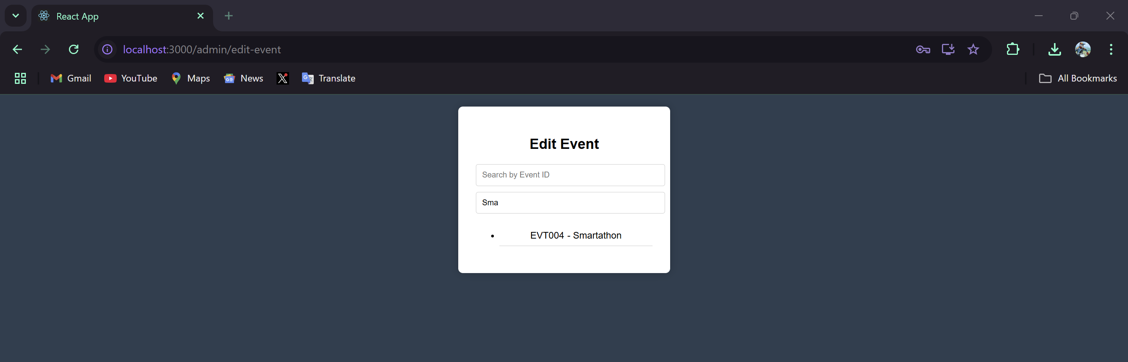

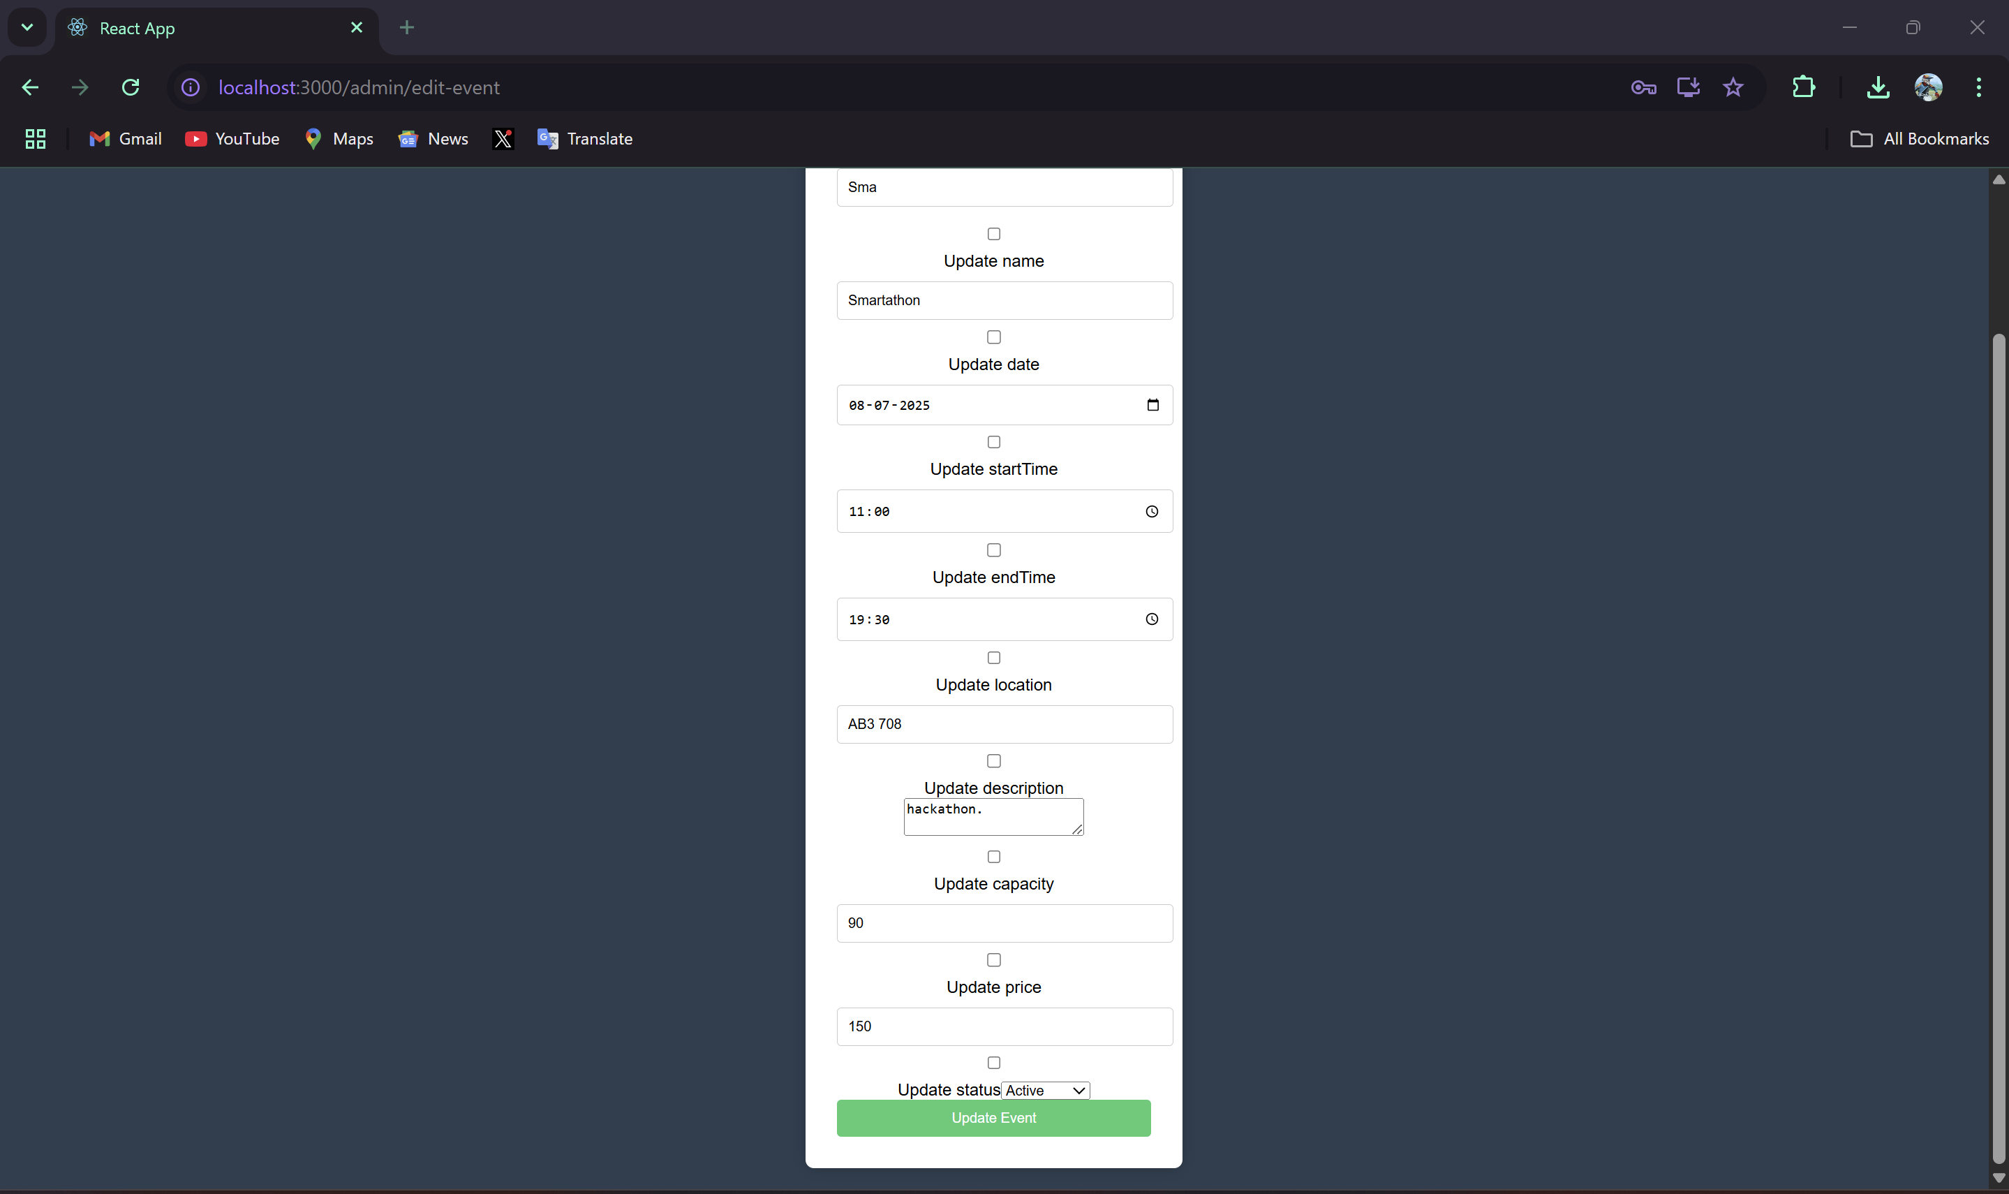

The check boxes here ensure that only those fields of the collections get updated and not others. Thus, it's necessary to turn the check boxes of the field that needs to be updated.

**We are gonna change the name and price of the event**

**status here has two options active and completed to ensure that the event is stsill active**

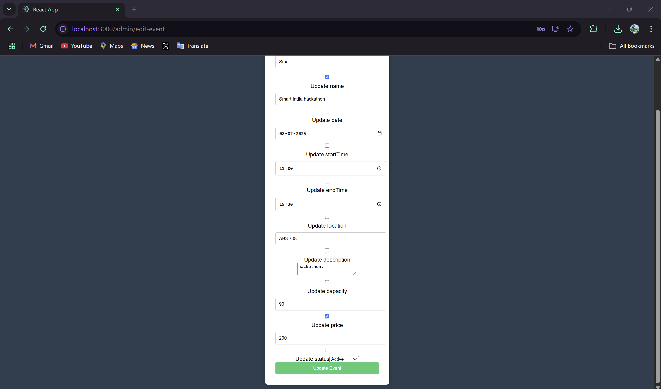

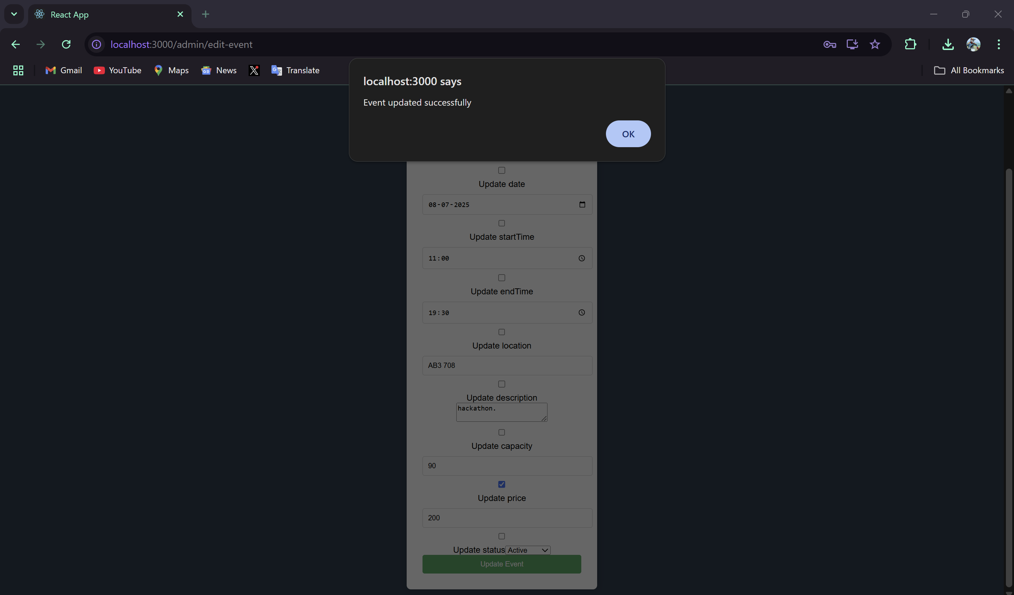

**Update in the collection is done [NOTE: EventID (EVT004) cant be edited as it acts unique index]**

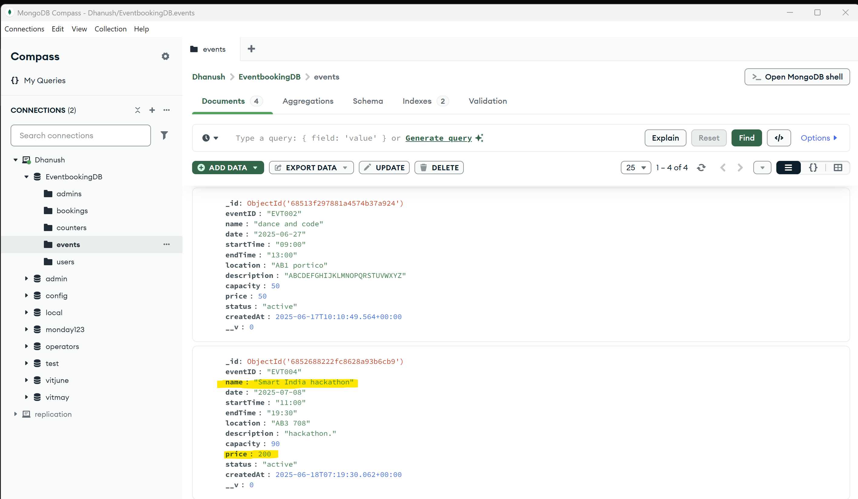

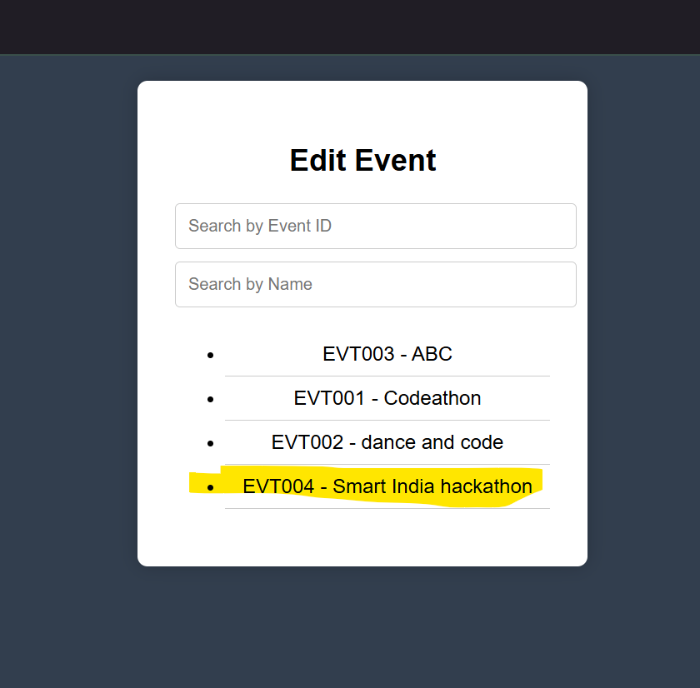

**Deletion:  
we will delete the event we added currently:  
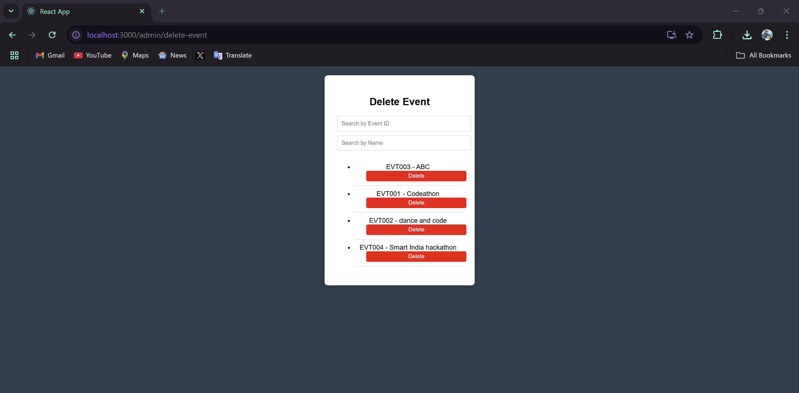**

We are deleting EVT004

Here too, search bars can be used, but since we have only 4 events we're gonna delete it directly.

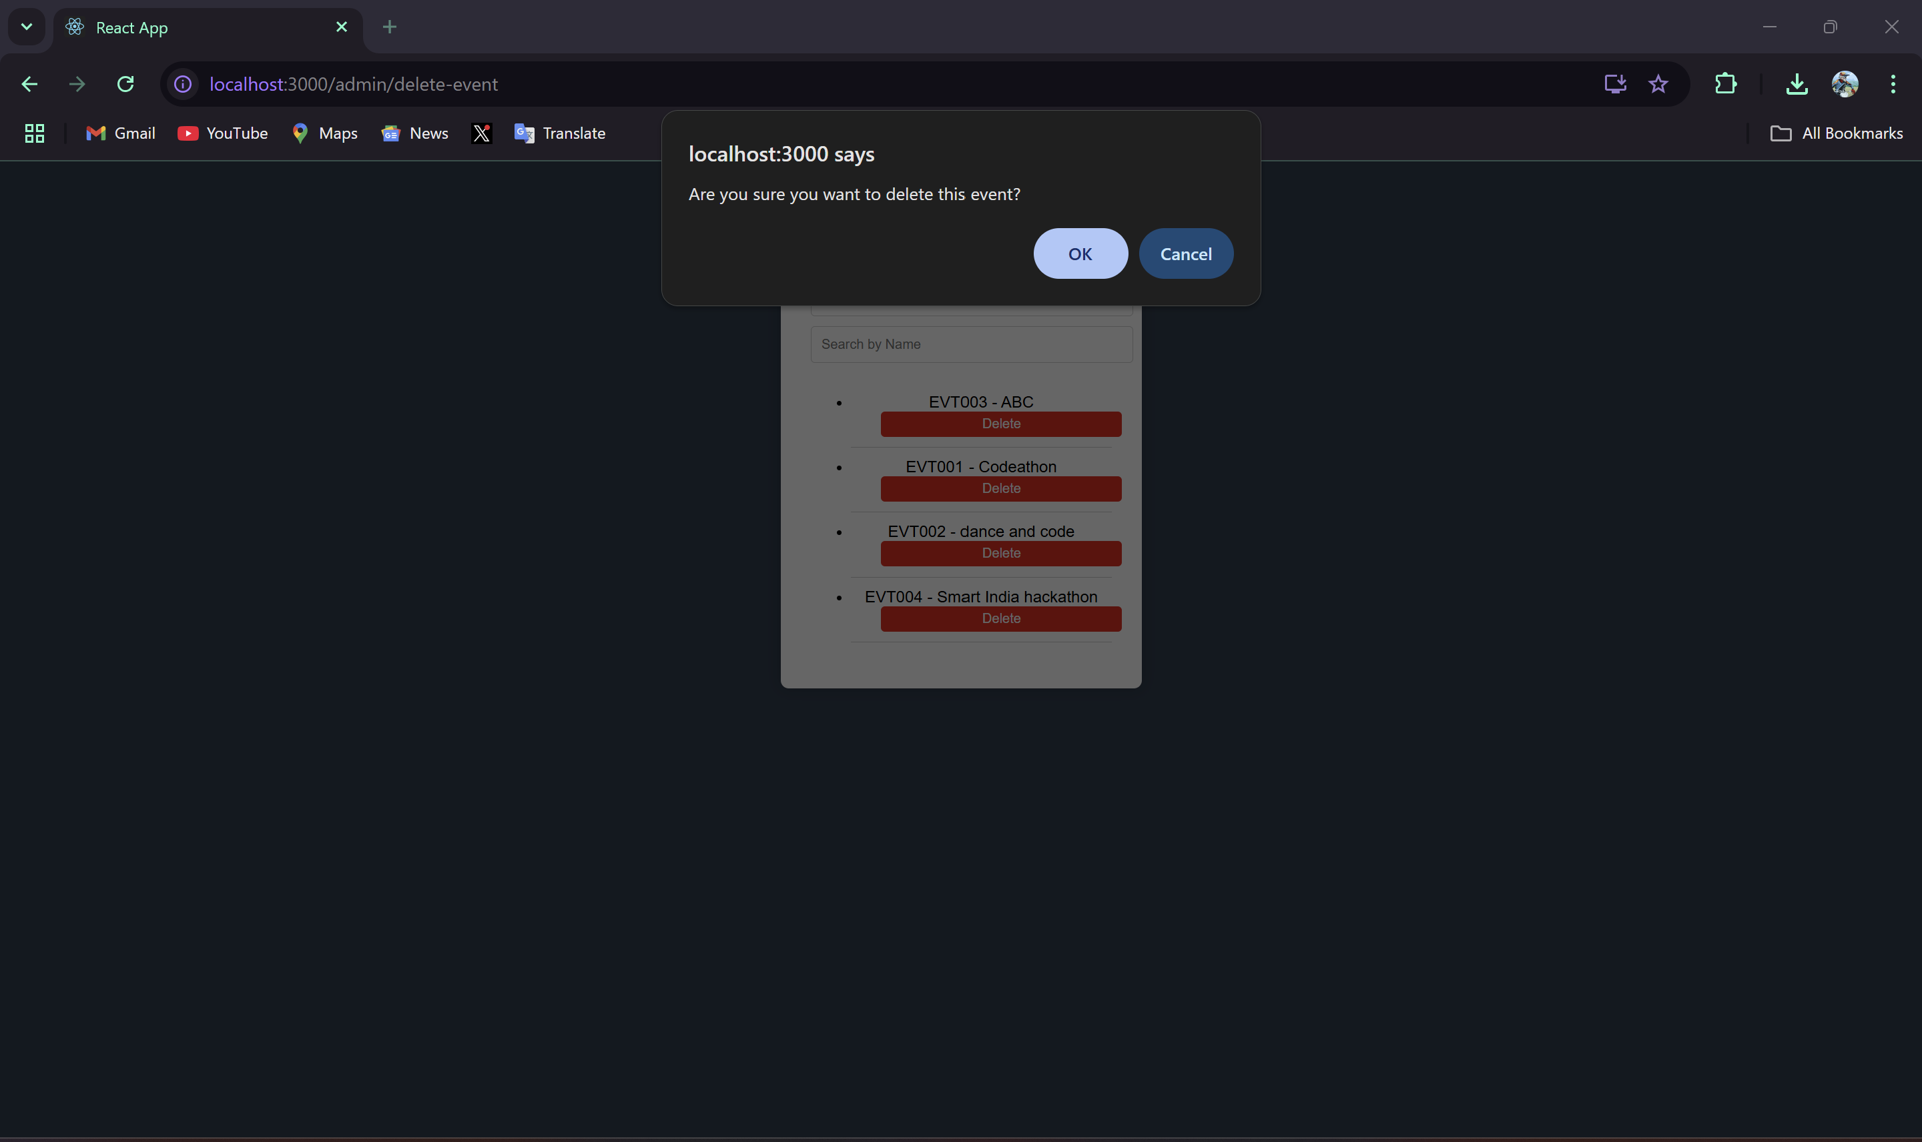

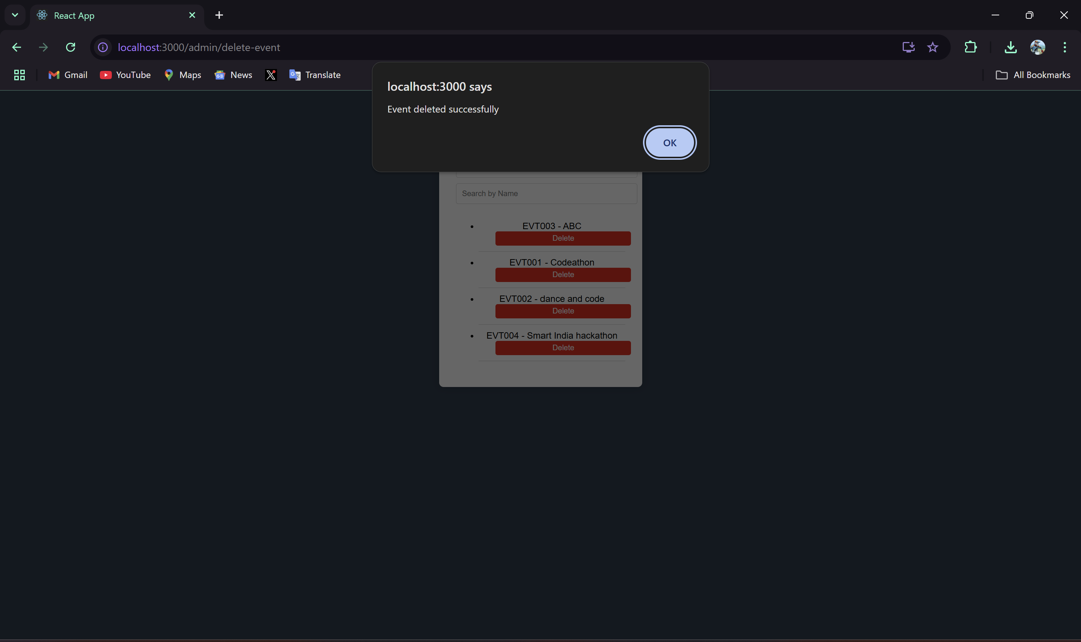

Successfully deleted

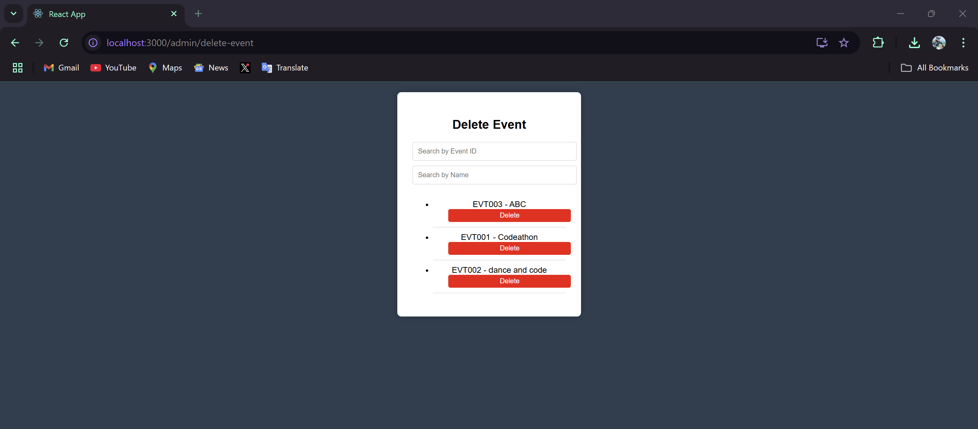

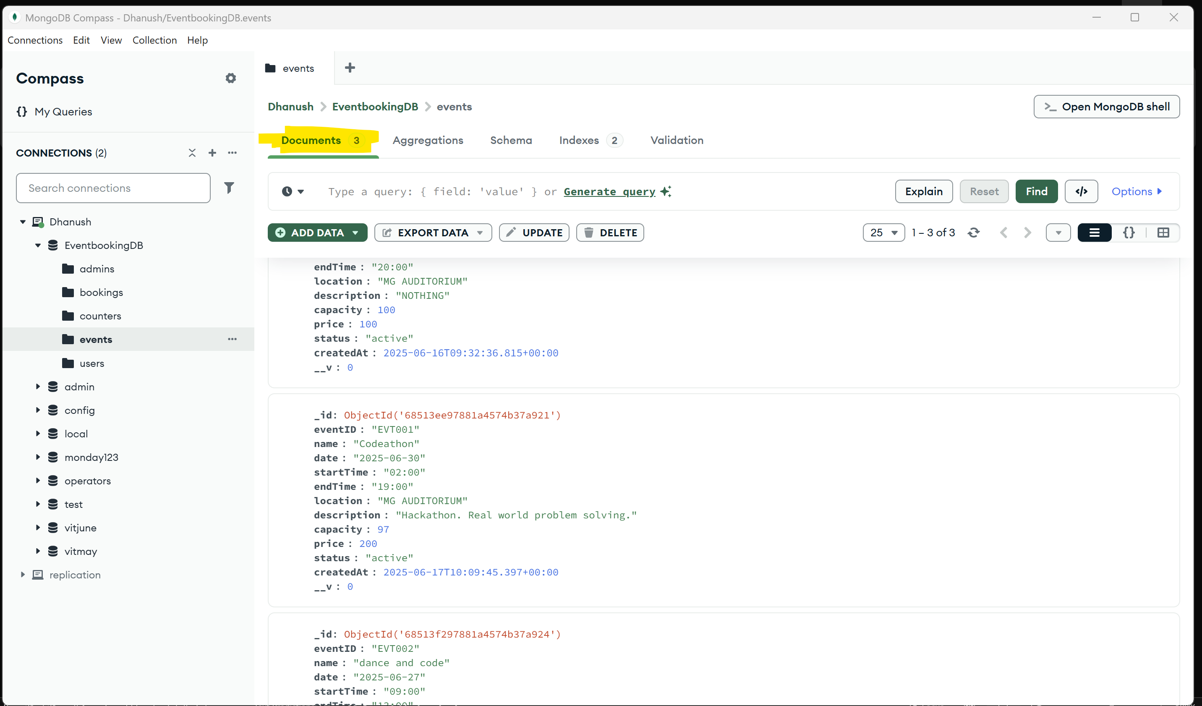

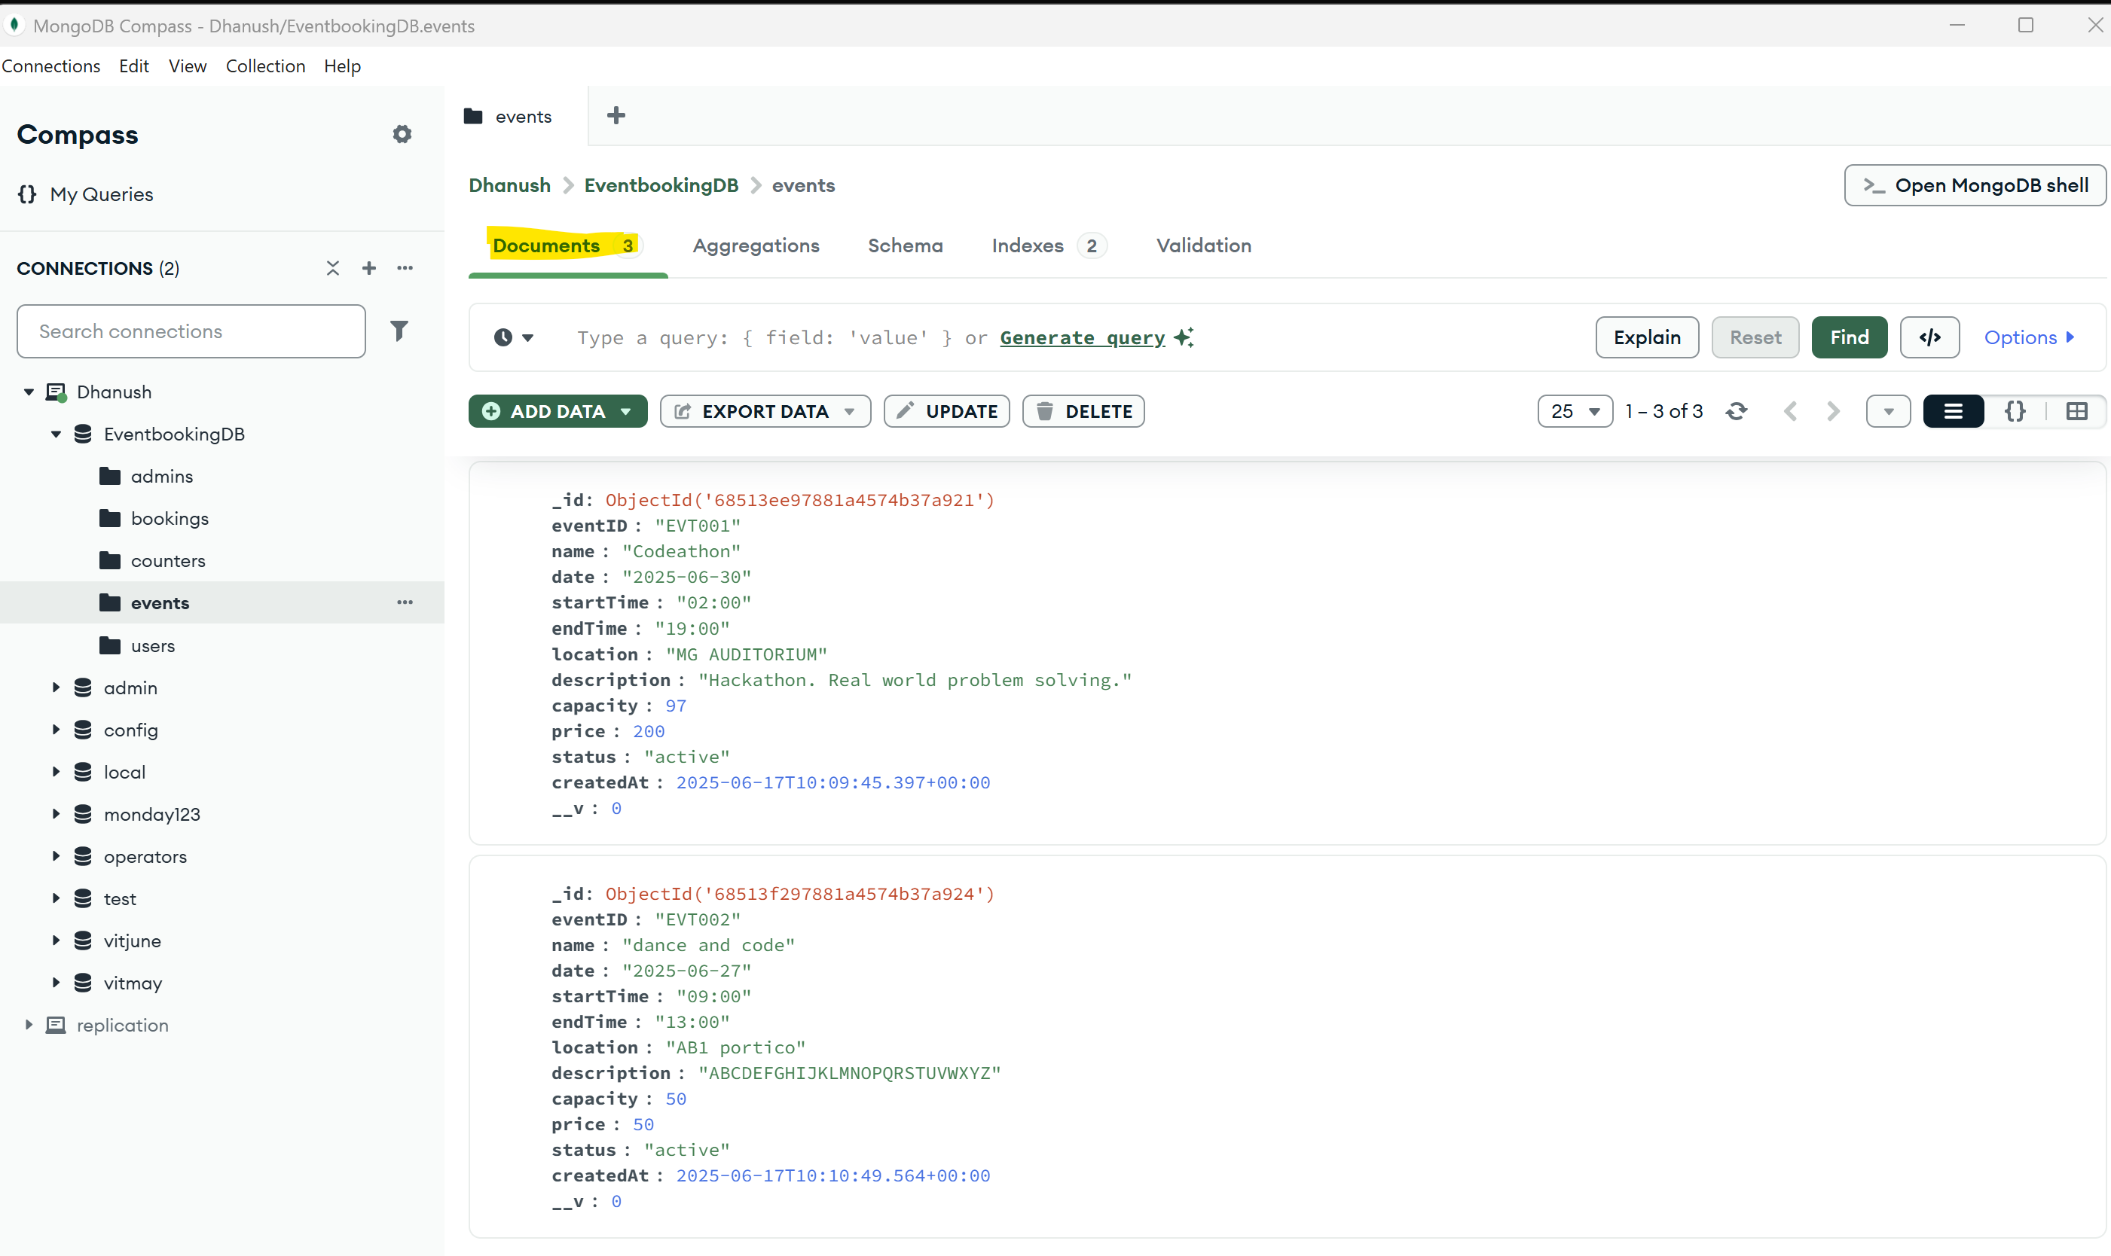

Only the docs can be viewed as we deleted the 4th EVT

**VIEWING ALL EVENTS INFO(There are three events as of now in the collection)**

